**Team Project Report**

**Deco2500 Human-Computer Interaction**

**Team HDY**



Group Members:

Lianzhan Gao s45679023

Yi Yang s45865590

Zhenyu Ding s45250673

Jescy Yu s45807460

1. **Introduction**

Our selection of topic issue is designing a fitness app in the aspect of diet and exercises. The detailed mind map of this issue can be found in **appendix 4.1 – project mind map.**

In this article, the interaction design of the project will go through a medium-fidelity evaluation and a high-fidelity evaluation to achieve a better user-centric landing solution. The detailed results of the update will be shown in Prototype.

1. **Devise requirements**

In order to determine the update of the medium fidelity prototype, it is necessary to figure out the user requirements. The design team needs to establish the appropriate user-system interaction logic based on the user's requirements as the basis for the high-fidelity prototype and subsequent updates.

* 1. **low-fidelity user test**

It is necessary to do user test about low-fidelity prototype to know the design defects existing in the current system to identify system requirements. The Technology acceptance model (TAM) was selected as the evaluation method in this session.

* + 1. **Introduction**

The **Technology Acceptance Model (TAM)** is a theory that used to analyze, evaluate and identity important elements that will affect users’ attitudes, acceptance level of targeted technologies.

In the evaluation session, participants are asked to do user tasks and rating for each question in TAM questionnaires. After that, users who rating low values for each question will be asked questions to get supplementary opinions. The TAM2 model is selected in this session for more comprehensive reflections from users. The protocol and analysis details are on **appendix 1 – low-fidelity prototype evaluation session**.

* + 1. **Analysis results**

Through the analysis of low-fidelity prototype evaluation, some issues are reflected about the current systems. Hence, the following affinity diagram was generated to summarize these issues which are divided based on dimensions of TAM to help on identify system requirements.

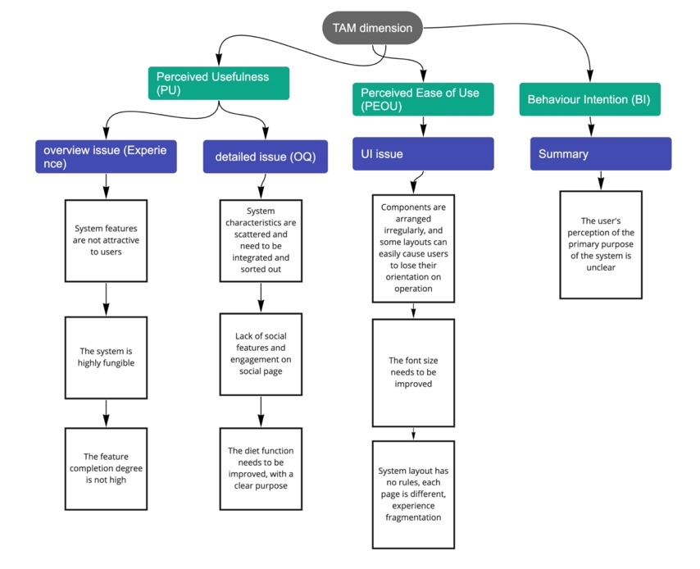

**Figure1: low-fidelity prototype issue summary affinity diagram**

* + 1. **System concept update**

Due to the analysis result, the system conceptual statement was devised. Compare to the previous conceptual statement, the new conceptual statement further explains the function and purpose of the system because from reflection on BI in Figure1 indicates that “The users’ perception of the primary purpose of the system is unclear.” The previous conceptual statement doesn’t show the comprehensive explanation of how system works. Here is the conceptual statement:

Design and develop a fitness software that can be used on mobile phone, including two parts: diet and exercise. Users can customize fitness plans according to their personal circumstances and goals, and fitness classes include professional video demonstrations and voice instructions. In the diet page, the user can find the food, check the corresponding calories, professional diet and preparation guidelines, and record the calories of the food. Therefore, the system will automatically calculate the user's calorie intake and consumption according to the user's exercise data and diet records, and report to the user. On the social page, users can share their training results.

* + 1. **Design guidelines**

Due to the issues identified from the analysis in the affinity diagram (figure1), some of the initial design guidelines (appendix 4.1 – project mind map) were revised and some new design guidelines were devised.

The design guideline **“aesthetic, behavioral and feedback consistency”** was specified into three design guidelines because of the reflection on UI issue in figure1. The three design guidelines **are “Layout and component consistency”, “operation consistency” and “reflection consistency”.** These design guidelines were identified for solving UI issue in three parts: display, usage and visual. “Layout and component consistency” means that in future UI design, the color matching and component layout of each page should be consistent. This does not mean that the pages of the software will be the same, only differentiated by changes in content. This conflicts with the design guideline "Strong Contrast Page Design". The key to aesthetic consistency is consistent font, shadow collocation, and control size. The core of consistent component layout is that controls representing the same functionality should be in the same location on each page. The benefits of this are to reduce the user's learning cost, information search time and operational exploration time, and avoid the user's confusion when switching between pages. This helped significantly with the UI issues reported in Figure 1.

The design guideline **“user control and freedom” and “explicit & implicit personalization”** were deleted due to the detailed issue (OQ) in figure1 since excessive customization and personalization can distract users from the features of the system. Additionally, the new design guideline **“automatic processing” is added.** The system is expected to replace user choice by automating some of the less common or cumbersome customizations and personalization, which will help them focus on the features of the system and avoid interference. At the same time, automation can also force the features of a system closer together by integrating some of the features that are common to the business.

The remaining design guidance will remain the same because no issues involving them were found in the previous evaluation, so they will continue to serve as the guidance for the subsequent design until issues involving this design guidance arise in the following evaluation.

* + 1. **System requirements**

Similarly, some of the initial system requirements were revised and some new system requirements were devised and added.

The system requirement **“view and share exercise results” need to be developed into** **“view and share fitness life”**. One of the participants on low-fidelity prototype evaluation session reflected that “Social community only can share exercise result, but I want to share more about my fitness life”, and another reflected that “I want to reply to poster, and not follow functions”, that is, the social page needs to be expanded to contain more functions. Despite of share exercise result only, social page should support on sharing other subject matters content about fitness like fitness life, body shape and so on. And **“interactive Interaction”** should be added to support reply, collect, and share functions on post to increase attraction of social page. And another system requirement **“private interaction”** has also been added to allow “follow” and “private message” functions to make the whole online social communication experience.

Additionally, the system requirement **“diet category”** and **“Customize portions”** is added based on the issue reflected in figure1. The reason that adds “diet category” is because one of participants on low-fidelity prototype evaluation session reflected that “I don’t want to search food one by one”, and the reason that add “customize portions” is because another reflected that “Sometimes I eat a lot, sometimes I eat a little, but I only see a certain amount of food calories”. Thus, the food in diet page should be categorized in simple by breakfast, lunch, and dinner with search bar, and when user add foods, they can select the magnitude of one meal by milliliter and gram.

Last, the system requirement **“quick run”** is added since one of the participants on low-fidelity prototype evaluation session suggests that “In some fitness apps, users can go for a quick outdoor or indoor run through a single page”. This was a great inspiration for us, as this feature greatly reduced the number of steps users had to take, and for some users who wanted to run, it would be tedious to spend a long time searching for courses. If the system supports a quick entry point, then running training can be more comfortable for the user. The process from clicking on the app to clicking on the run is much smoother and more natural.

The remaining system requirements remain unchanged until questions arise about these system requirements in subsequent evaluations.

* + 1. **High level description**

The high-level description will also be extended to include an overview of the updated design guidelines and system requirements, based on the updated design guidelines and system requirements. Here is the high-level description:

The system is designed to provide healthy or purpose-specific people with calculations and recommendations of calories burned in exercise and diet.

It will record physical data and targets via a mobile app, giving detailed reports of consumption and intake.

It will allow users the flexibility to choose their workouts or choose from a database of fitness videos, both of which will provide calories burned and record them at any time.

It also offers full fitness recipes and tutorials, as well as the option to count calories by recording the weight of different foods.

It also allows users to post about their fitness routines, and allows users to respond to posts, follow and chat privately.

* + 1. **summary**

|  |  |  |  |  |  |
| --- | --- | --- | --- | --- | --- |
| Design guidelines | Layout and component consistency | Operation consistency | Reflection consistency | Automatic processing | Simple and strong contrast page design |
|  | new | new | new | new | old |

|  |  |
| --- | --- |
| System requirements | parts |
| View and share fitness life | social |
| Interactive interaction | social |
| Private interaction | social |
| Diet categorizes | diet |
| Customize portions | diet |
| Calories of different food | diet |
| Diversity of recipes | diet |
| Exercise video to accompany the exercise | exercise |
| Quick run | exercise |
| Periodic data reporting | exercise |

* 1. **persona**
     1. **Introduction**

Persona is a fictitious character created based on the results of our research. The purpose of doing persona is to create a representative of several different user types that may use our application, to better judge our future target groups. The advantage of persona is that it can help us understand the purpose of the users who use this application, and they all act to help us better improve the content and functions of this application.

Before we were ready to do a persona, we did an interview to collect data about user experience, pain points and goals. In the interview, we prepared 10 questions and the interview result is used to create different personas. Here are the questions:

|  |  |
| --- | --- |
| Your age, gender, occupation. | The purpose is to know the basic information of the interviewee to determine the target audience. |
| Why do you use fitness software? | The purpose of this question is to collect the purpose of using the application, which is the same as the purpose of the fourth question in the survey, except that this can get more detailed information. |
| What fitness software have you used? What aspects of it attracted you? | The purpose of this question is to collect the fitness software that users have used, and get them attracted by these applications, to better improve our applications. |
| What do you think are the deficiencies in the functions of the software you are using? | The purpose of these questions is to collect the inconveniences that users encounter when using other software, so that we can avoid these disadvantages when building application functions. |
| When you use software for fitness planning, do you prefer free customization or automatic generation by the software? | The purpose of this question is to know whether the person's diet can affect fitness. |
| Do you think healthy eating is helpful for fitness? | The purpose of this question is to know whether the person's diet can affect fitness. |
| Do you prefer to cook according to dietary recipes or do it yourself? | The purpose of this question is to know whether the interviewee will plan and cook according to some fitness recipes. |
| Will explicit calorie calculations motivate you? | The purpose of this question is to know whether the interviewee thinks that the calorie recording tool can motivate them to lose weight. |
| For you, what are the three most important functions of a fitness and diet exercise software? | The purpose of this question is to know the three more important functions in the fitness application that the interviewee considers. |

In the collection of interview data, we interviewed a total of 10 people where their responses are very valuable to us. Base on the collected data, we made an affinity graph about persona. The interview result

is located on **appendix 5 – interview result**. Furthermore, we summarize the interview results and present the summarized data into an affinity diagram (figure2) which allow use to intuitively know the problems we are facing.

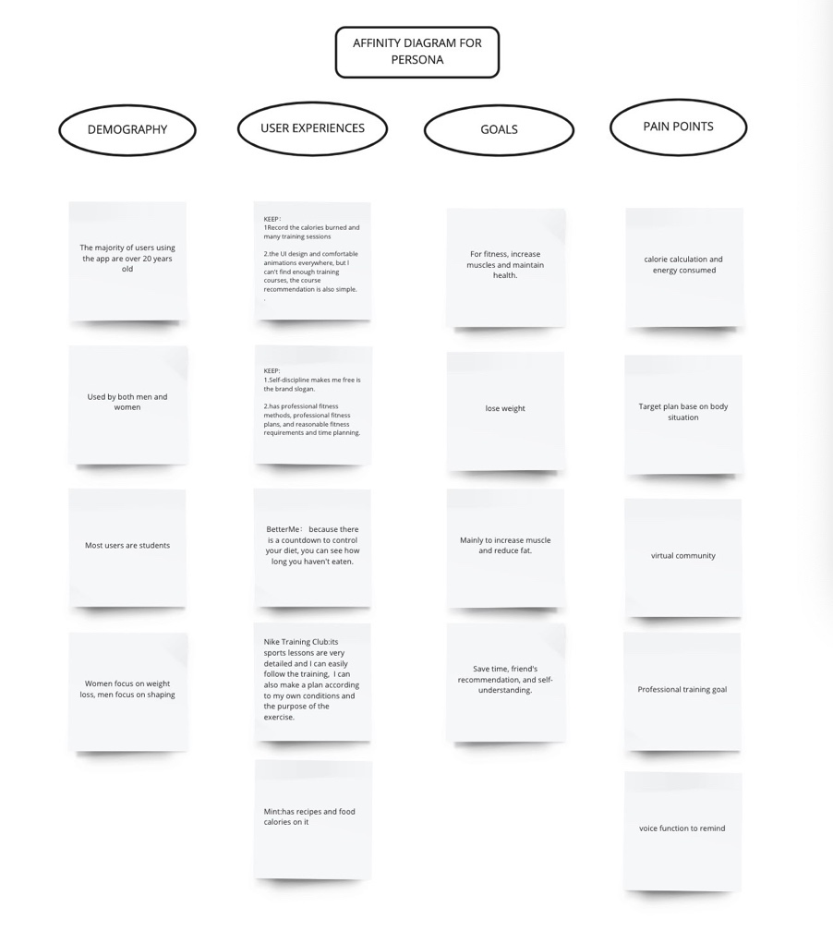

**Figure2: interview summarized data**

* + 1. **persona explanations**

Based on the interview summarized data, there are 3 typical users were identified due to the fitness goals, fitness behaviours and fitness experiences from 10 interviews. These typical users are representing “fitness enthusiast”, “obese people” and “the procrastinator”. And there are 3 personas generated based on these three typical users.

Ivan, a typical 'fitness enthusiast', has used apps to help lower his BMI. He hopes that trying out a new fitness system will help him make changes to his body and increase his social appeal. Ivan is a microcosm of the people who want to improve their health and image through fitness. Therefore, for the "fitness crowd", the system can effectively help them to make changes, they can improve their physical fitness through the exercise program, and at the same time, with dietary advice to improve the intake of nutrition.

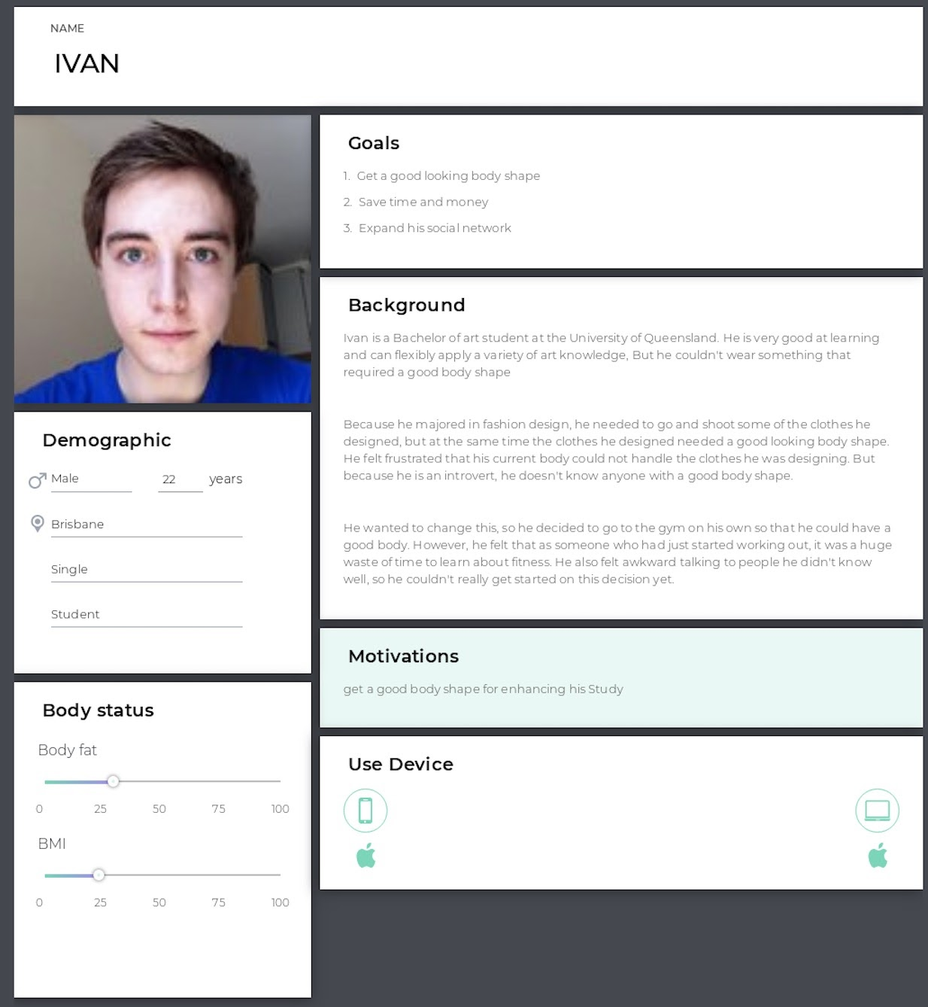

**Figure3: “fitness enthusiast” persona**

For the "obese people", most of them had never touched fitness software before, or even worked out less often. This man, Alan, is a typical example, because he is an employee of the company, and his exercise time is limited to a certain extent. He doesn't know how to start working out. According to these conditions, he can use the fitness plan on the app to customize a workout time, so that the system can help determine a reasonable workout plan according to the workout time given by him. And when he is doing exercise, he can use the motion correction function, so that he can avoid doing some actions that harm his body.

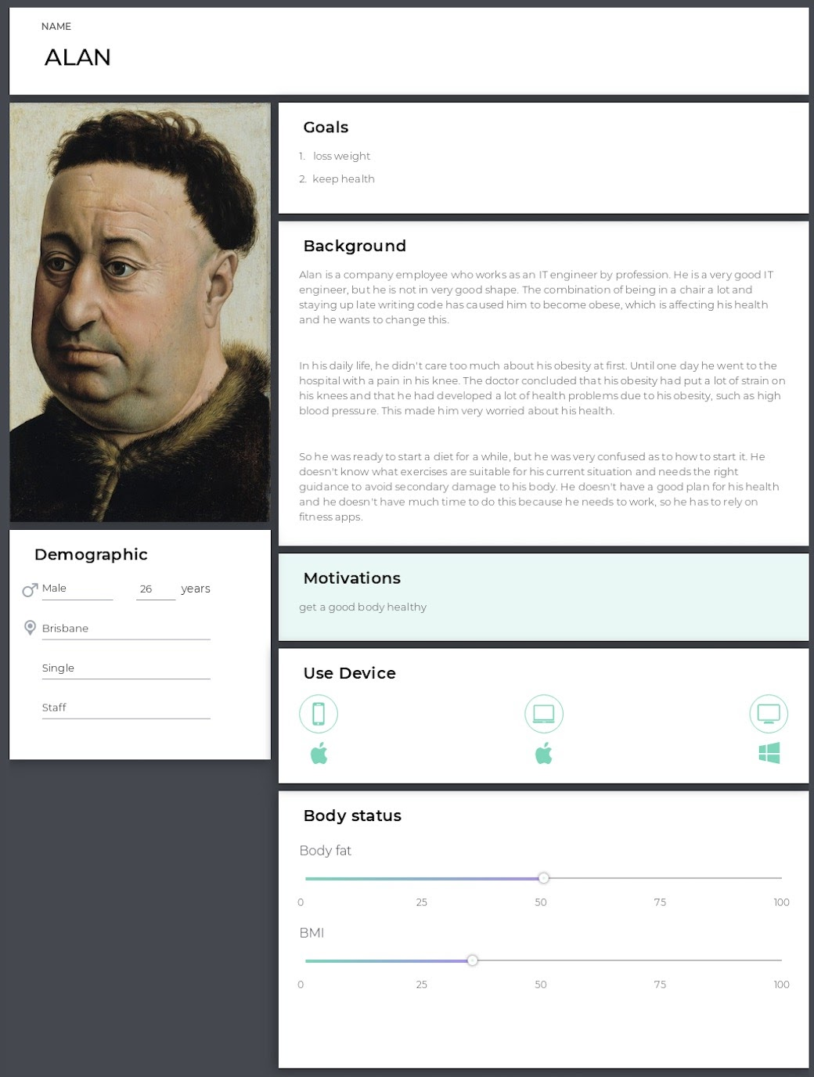

**Figure4: “obese people” persona**

Another typical user is "the procrastinator", Wendy, who wants to try out a new fitness app to monitor her weight loss, so that she can regain her old weight within a certain period. For procrastinators, the system can remind them to exercise through regular push, which can urge them to make progress to a certain extent.

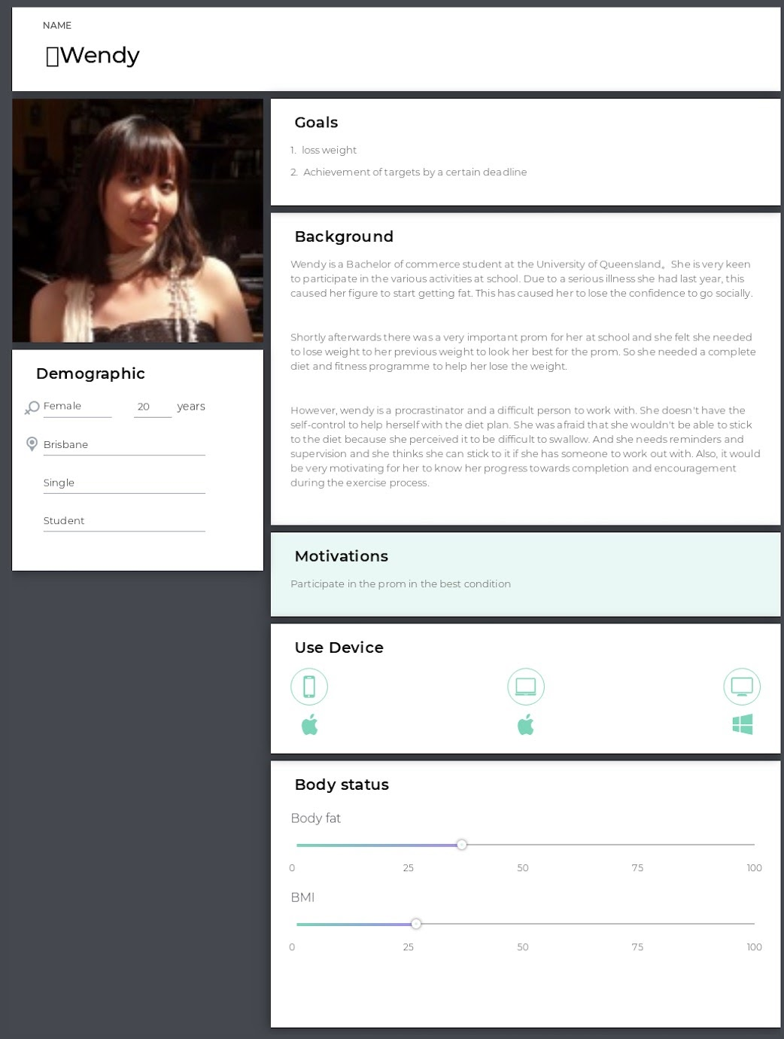

**Figure5: “the procrastinator” persona**

* + 1. **Interaction scenarios**

To better recreate different scenarios of “typical users” using the system, two interaction scenarios were built. Through the description of interaction scenarios, I can consider the feelings and attitudes of users when using the system from the perspective of users.

Figure 6 shows how Ivan use the system to increase body shape, figure 7 shows how Elan make plan and do exercise, and figure 8 shows how Wendy be noticed by the system.

By making interactive scenes, I have a further understanding of the needs, activities and motivations of users.

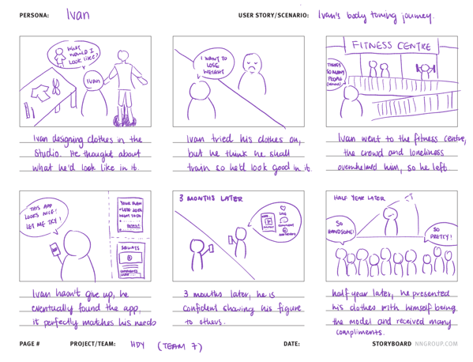

**Figure6: “lvan” ‘s interaction scenario**

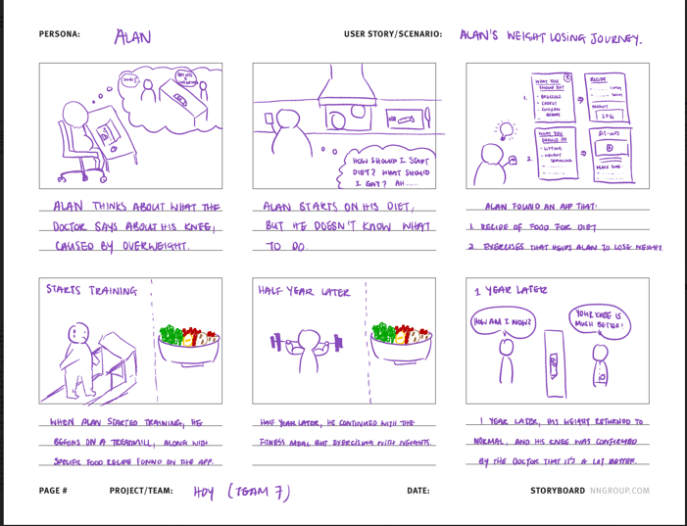

**Figure7: “Alan” ‘s interaction scenario**

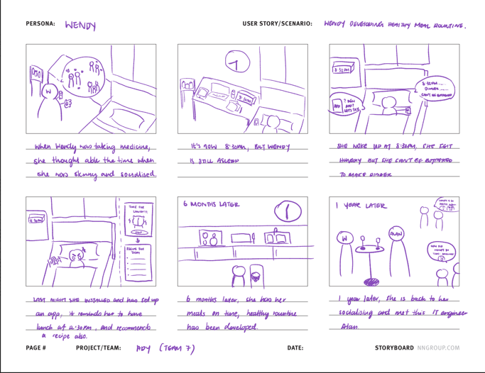

**Figure8: “Wendy” ‘s interaction scenario**

* + 1. **UX Goals**

To further broaden the understanding of users' requirements for the system, the team summarized a series of UX goals based on survey and interview results. The reason for using UX Goals is that it is a good way to measure users' satisfaction with the system they are using to gauge their expectations for a fitness system. The summary of UX Goals can help the design team to carry out the follow-up development better.

The summarized user expectations are then further analyzed and UX Goals are generated in accordance with SMART criteria. SMART criteria are used to measure whether a UX goal can be taken seriously. After determining UX Goals, the corresponding UX Measure based on the user's experience will be analyzed. After this, the requirement based on UX Measure will be determined and considered whether it is suitable for the existing system.

The identified UX goals are below:

|  |  |  |  |
| --- | --- | --- | --- |
| Source | UX goal | UX measure | Requirement |
| “Lack of long-term exercise plan and lack of reasonable dietary requirements for fitness.  ” From interviewee 7  “Can also make a plan according to my own conditions and the purpose of the exercise.  ” From interviewee 5 | I want to have a regular exercise plan and keep doing it in schedule | 1. Long-term expectation 2. Initial performance | 1. Create exercise plan 2. Personalized training schedule settings |
| “l dislike messy component layout, useless information always wastes my time for searching useful things, especially some advertisements of paid courses.  ” From interviewee 6 | I want the GUI signs, buttons as well as other components that represent different contents be simple and intuitive | 1. Initial performance about UI design 2. First impression about UI design | 1. Neat layout 2. Systematic design style 3. Navigation, control bar and buttons |
| “The animation is just right and attractive” from interviewee 5 | I want the animations to be smooth, meaningful and with suitable pace | 1. Long-term experience 2. Long-term expectation | 1. Transfer animation 2. Process Animation 3. Pop-up animation |
| “l can't find enough training courses; the course recommendation is also simple. For me, this application is “humble”.  ” From interviewee 6 | I want the course database to have rich courses that cover as much as possible aspects of exercise | 1. Long-term expectation 2. Flexible experience | 1. Course categorization 2. Course search |
| “Control your diet and record how much you eat every day.  ” From interviewee 4 | I want to record how many calories that I consume in exercise and how many calories that I eaten | 1. Long-term expectation 2. Long-term performance | 1. Calories record 2. Calories report 3. Calories calculation |
| “But the component layout is messy so that l cannot keep the focus on the elements that l am interested in.  ” From interviewee 6 | I want the important components especially the navigate components can be highlighted | 1. First impression 2. First performance | 1. Highlighted component 2. Contrast color design 3. Texture usage |
| “Another thing is that their animation is not unified so that when l am on similar pages the interaction mode is different so that l felt unfordable.  ” From interviewee 6 | I want to have similar pages have unified animations | 1. Long-term performance 2. Long-term expectation | 1. Systematic animation |

1. **Medium fidelity prototype**

Based on the evaluation analysis result, devised design guideline and system requirements, and following personas, interaction scenarios, and UX goals, most of issues found from evaluation session about low-fidelity prototype were covered and in the medium fidelity prototype, design team tried to cope with these issues by adding new features and optimize into the medium fidelity prototype.

The overall update of low fidelity prototype is adding features and UI layout optimization.

The features in medium fidelity prototype are in 5 parts, which are “community” refers to **social** communication, “personal” refers to **personal report and personal profile**, “exercise” refers to **exercise courses and exercise plan**, “diet” refers to the **diet intake calculation and diet recipe** and “message” refers to **system notification and private message**. The reason for integrating these features into different sections is to reduce the sense of fragmentation between similar features, to provide a more unified experience for users and to avoid the " System characteristics are scattered and need to be integrated and sorted out” issue as mentioned in Figure 1.

Medium Fidelity Prototype mainly uses black, white, and gray colors as the main colors, and at the same

time uses simple and large size components to display content, which is in line with the design guide "simply

and strong contrast page design" and the UX goals “I want the GUI signs, buttons as well as other

components that represent different contents be simple and intuitive”. In terms of UI layout, major titles

are used to indicate sections, bottom navigation bar is used to switch main pages by click, left and right

sliding controls are used to switch the sub-pages of each section, and unified ICONS are used to represent

specific operations. This is consistent with the design guideline "Layout and component consistency" and

"Operation consistency".

**Figure9: medium fidelity prototype overview**

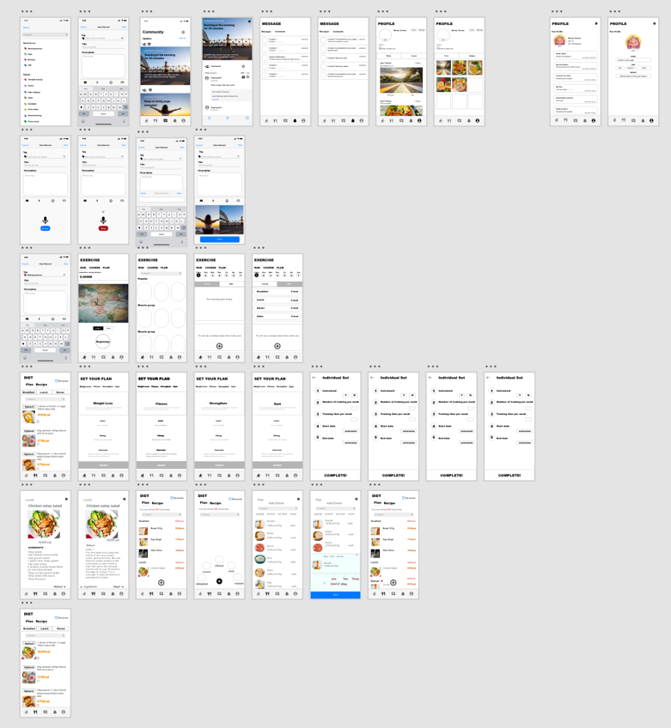

The navigation bar at bottom will fix in each main page of each part, users can simply press relevant sign to jump to the main page of the part they want to go.

For example, when press the “running man” icon, users will jump to the main page of “exercise”. The “running man” icon means the “exercise” part, the “knife and fork” icon means the “diet” part, the “chat bubble” sign means the “community” part, the “bell” sign means the “notification” part and the “man” sign means the “personal” part. When user stay in a part, the corresponding sign will be black, and others will be grey to make the part more obvious. This navigation design refers to UX goals “I want the important components especially the navigate components can be highlighted”.

 **figure10: navigation bar**

* 1. **Community**

Community part is the social communication part that user can share their fitness lives, browse others’ posts,

reply posts, collect posts, follow and private with other users, which refers to system requirements “private

interaction”. It contains 7 features to reach the system requirements.

.

**Figure11: feature summary of community**

|  |  |  |
| --- | --- | --- |
| System requirements | features | position |
| View and share fitness life | 1. posting posts 2. View posts | main page – view posts  post page – view posts, share posts  posting page – posting posts |
| Private interaction | 1. Follow poster authors 2. Private message | Poster page, Post page – follow poster  Poster page – private message |
| Interactive interaction | 1. Reply posts 2. Collect posts 3. Share posts | Post page – reply posts  Main page, post page – collect posts  Post page – share posts |

**Figure12: main page of community**

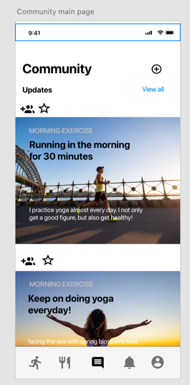While users operate in this page, they can scroll up and down to **view posts**, and they can click the two icons in purple to **follow users and collect posts**. While they want to **post their own posts**, they can press the icon in red circle to enter the posting page for posting their own posts. Additionally, if users want to reply to posts, they can press the post and will jump to relevant post page.



In this page, because the user needs to view the posts, each post takes up a large space on the page and uses the post image to attract the user and highlight the post.

The reason why the system icon is black is to increase the contrast with the white background. In this prototype, all titles and subtitles are in bold black font to make the important content stand out in the background, while minimizing the extra elements on each page to make it easier for users to find the access point. This design refers to the design policy of "simple, strong contrast page design".

**Figure13: posting page**

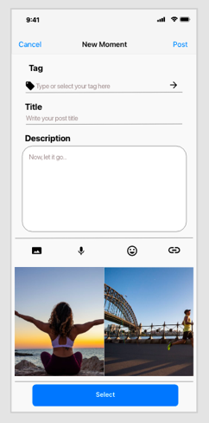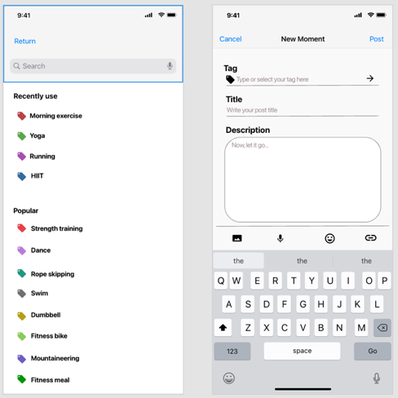

In this page, users can **post their posts**, they need to fill in the post title and description in the text box, and press “image” icon in the purple circle to add cover, and press “select” button to finish selection. After that, they can press “post” in the green circle to post. If they want to add tag for their post, they can press the enter icon in tag text box to enter the tag page to add tags.



Additionally, users can press “cancel” in orange circle for cancellation.

**Figure14: post page.**



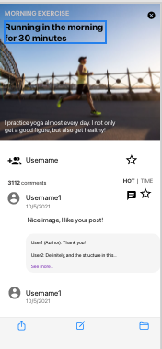This is the post page, users can view details of a post and comment **and reply, share and collect posts here.** Users can press the icon in yellow circle for close this page. Post collection can be done by select “star” in grey circle and reply comments by press “bubble” in red circle. Additionally, in the navigation bar, users **can reply posts by press icon in green and share by press icon in blue.**



In the orange circle, user can press the username to see the author’s profile and **make private message** here and also can press the icon to **follow the author**.



**Figure15: poster page**



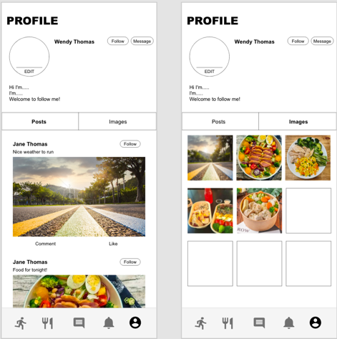This is the profile of post authors, while users can view the historical posts of relevant authors. In this page, users can make private message with the author by press message button in orange circle, and **follow author** by press the follow button in blue circle.



Users can also scroll left and right to switch pages between “posts” and “images”.

* 1. **Personal**

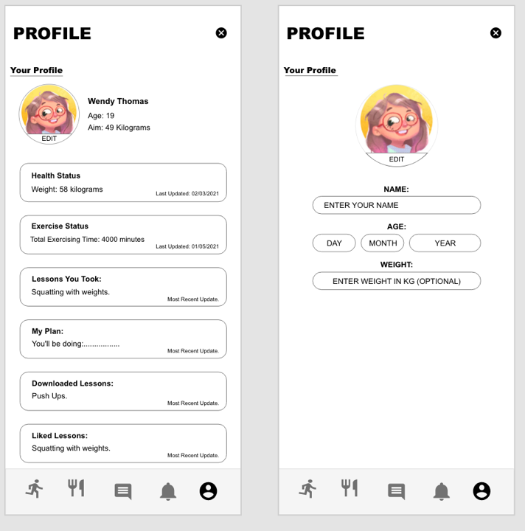Personal page mainly shows the profile of users, while users can see the periodic report here which refers to the system requirement **“periodical data record”** and UX goals **“I want to record how many calories that I consume in exercise and how many calories that l eaten”.** Actually, the periodical data record is the comprehensive total record of user consuming periodically.

In this part, despite that user can check their report by press “health status” and “exercise status” here, they can also check their exercise plan by press “my plan”, exercise courses by press “lessons” and download courses by press “download lessons.”

**figure 13: personal page**

* 1. **Message**

This page mainly shows the notifications that from comments that others reply on user’s post, private message and system notifications to notice for making exercise. When the system notification be pushed, there will be a alarm with vibrations to notice users due to the exercise schedule.

In this page user can scroll left and right to switch subpages between “message” and “comments”

**Figure14: message part**

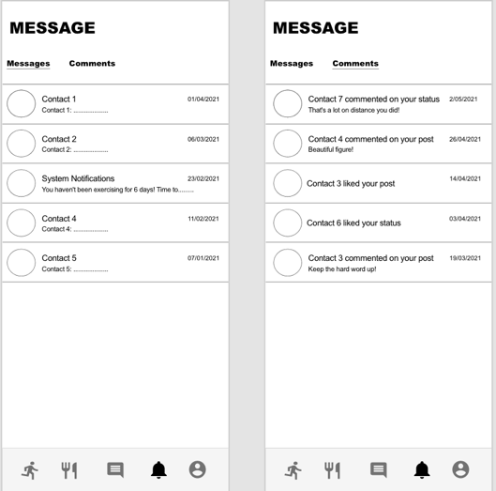

* 1. **Diet**

Diet part is the part that users can look for diet recipes in the interface, and the quantity of heat of different kinds of food, at the same time can also be calculated by choosing to eat food every day intake of calories, the system will automatically record the user of the calories consumed, and based on the user's body data as well as the exercise of the user to calculate the user's daily consumption, and combined with relevant knowledge generated report regularly, This is consistent with the design guide "Automatic Processing".

It contains 4 features to reach the system requirements.

**Figure15: feature summary for diet**

|  |  |  |
| --- | --- | --- |
| System requirements | features | location |
| Diet categorize | Diet categorization | Recipe page, plan page |
| Customize portions | Diet portion selection | Add food page |
| Calories of different food | Food calories display | Recipe page, plan page, add food page |
| Diversity of recipes | Recipes for each food | Recipe page |

**Figure16: food search and recipe check flow**

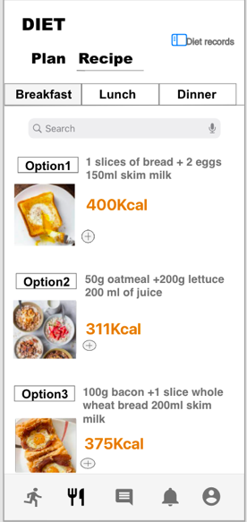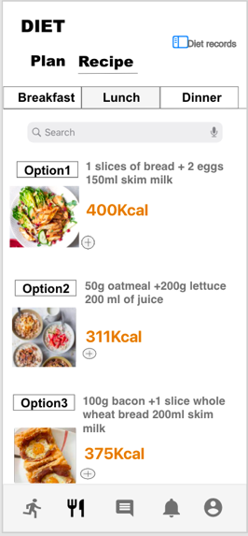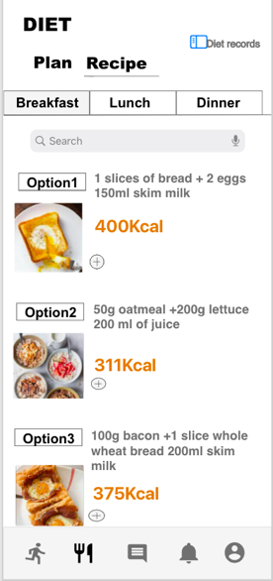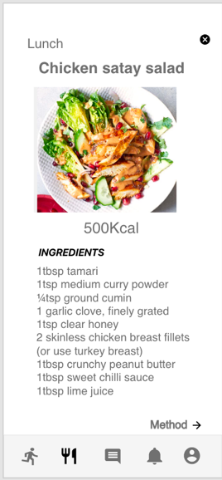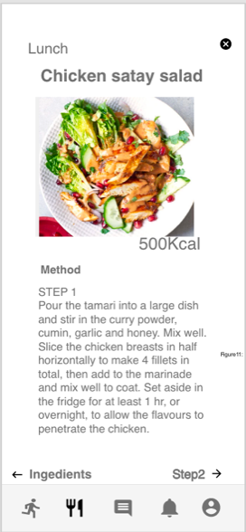



This is the operation flow that user search foods and check the recipe details. It contains 5 pages, and the first three pages are the recipe page and the last two page are the recipe details page.

In the recipe page, users can search foods by using search bar and see the calories of each food, which refers to the system requirement “Calories of different food”, and users can press foods to see the detailed recipe in recipe details page, this feature refers to the system requirement “Diversity of recipes”. In recipe details page, users can press the close icon in red circle to close the recipe. Users can also press food category to quickly switch foods between breakfast, lunch, and dinner.

Additionally, users can scroll left and right to switch subpage between “recipe” and “plan”.

**Figure17: calories calculation flow**

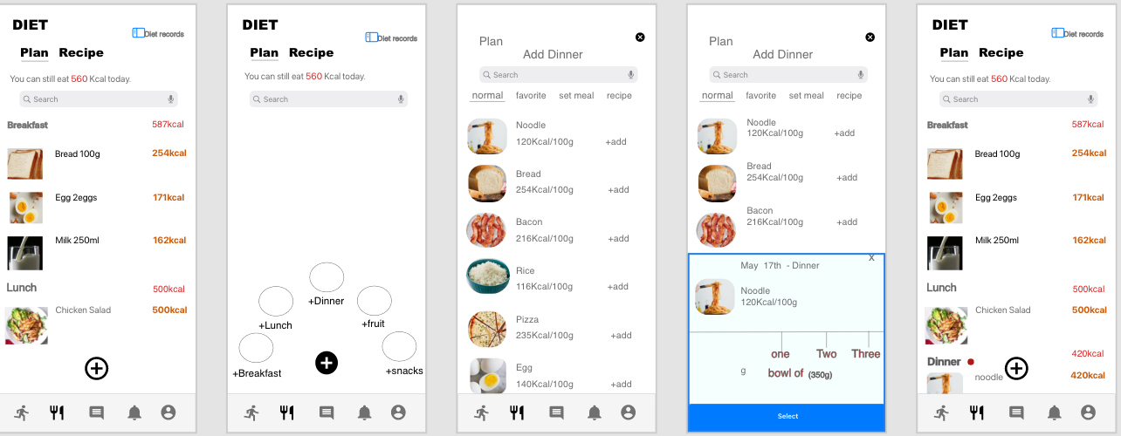



This is the calories calculation flow that users can add foods to calculate their intake. It contains 5 pages, the first page is the plan page, users are noticed by the up to date message to know how many calories they intake the day. The rest of the page shows the foods eaten with relevant calories which refers to system requirement “Calories of different food” and users can press the icon in the yellow circle to add foods. After press the icon, the second page will be displayed, users need to select food categories to select different food which refers to the system requirement “Diet categorize”, after they select the food category, system will automatically shows foods based on the relevant food category and recategorize into different parts in the add food page (4th page), which refers to the design guideline “automatic processing”. Users can select foods that want to add by selecting the portions (5th page). Users should scroll left and right to adjust needed food portion, which refers to the system requirement “Customize portions”. After that, users can press the “select” button to finish this flow.

* 1. **Exercise**

The exercise part is the part that users can make their own exercise plans and search needed courses. The exercise consumption will be captured by system and the comprehensive result will be shown in periodic report. It contains features based on the system requirements and UX goals identified before.

**Figure 18: feature summary for exercise part**

|  |  |  |
| --- | --- | --- |
| System requirement and UX goals | features | location |
| Quick Run | Run entry | Run page |
| Exercise video to accompany the exercise | Course demonstration video | Course page |
| UX goal1: I want to have a regular exercise plan and keep doing it in schedule | Exercise plan set up | Plan pages |
| UX goal4: I want the course database to have rich courses that cover as much as possible aspects of exercise | Course category  Course search | Course page |

**Figure19: Run page**

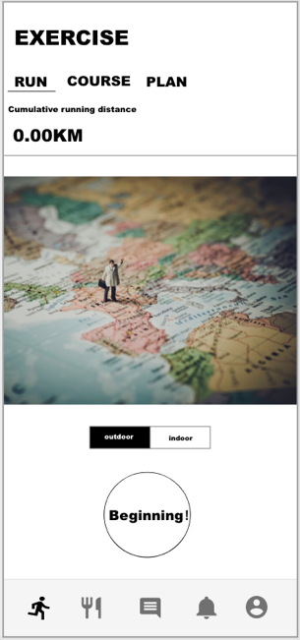Run page is the first page of exercise part, it aims to make the fast entry for users who want to run quickly, as reflection “In some fitness apps, users can go for a quick outdoor or indoor run through a single page”, users can press the “Beginning” button to make quick running, and select running mode by select the buttons in the orange circle. This refers to the system requirement “Quick run”, similarly, like the same operation in the plan page, recipe page of diet part, pages of message part, users can quickly switch subpages by scrolling right and left, this refers to the design guideline “operation consistency”, and due to that all the results by this operation are the subpage switch with transition animation, so that it also refers to the design guideline “reflection consistency” and UX goal7: “I want to have similar pages have unified animations”.



The figure 20 shows the course page, users can search needed courses by using search bar, and the rest of spaces shows the recommend courses by course categories, which refers to the UX goal4: “I want the course database to have rich courses that cover as much as possible aspects of exercise”. Users can press courses to follow the exercise video to do their exercise, this is refers to the system requirements “Exercise video to accompany the exercise”.

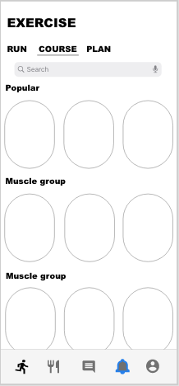

**Figure 20: course page**

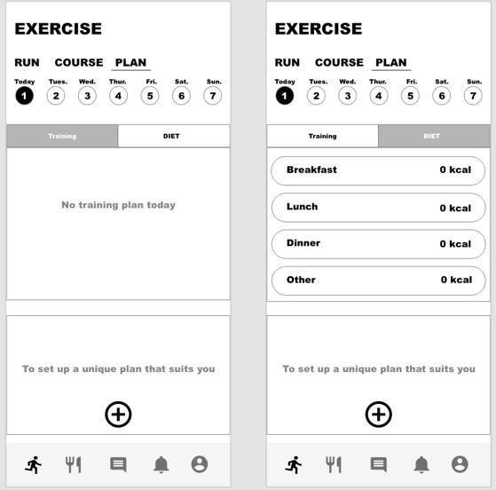**Figure 21: plan page**

This is the plan pages, users can check their scheduled plan by press date in date bar, and their added food will also be shown in this page by selecting “DIET” to see the daily total intake to make sure that how many calories consumption they need to do.

For add courses, users can press the icon in the blue circle, and then they can make their own exercise plans.



Figure22 shows the plan set up flow, users first need to scroll left and right to select the exercise type, and hence press the “start” button to make their personal selection by typing the instruments, number of trainings per week, and the start date and end of their exercise plan, this refers to the UX goals1 : “I want to have a regular exercise plan and keep doing it in schedule”

**Figure22: plan set up**

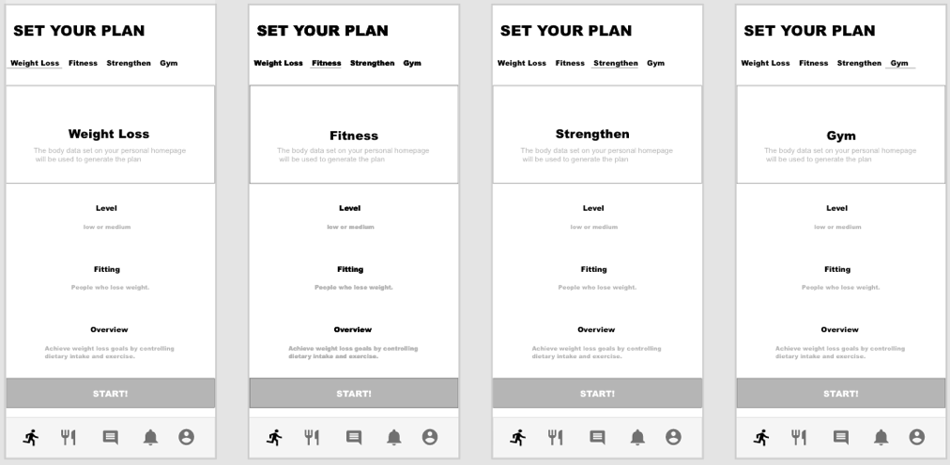

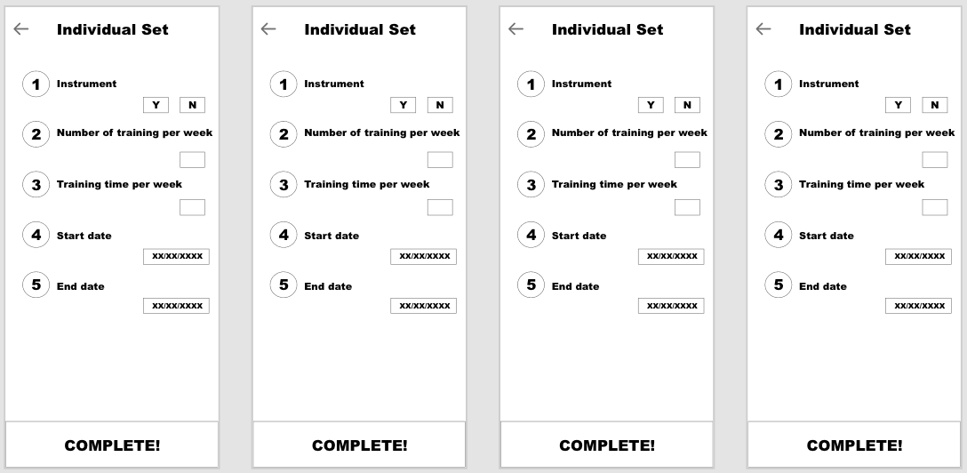

*The following link is the full version of the medium-fidelity prototype in Adobe XD:*

*https://xd.adobe.com/view/68985386-1940-4c79-8903-7e92ca4e2aee-3dcb/*

1. **Medium fidelity prototype evaluation** 
   1. **Evaluation method**

The evaluation method used for the medium fidelity protype evaluation is System Usability Scale (SUS).

* 1. **Background**

The System Availability Scale (SUS) was developed by John Brook of Digital Equipment Corporation in the UK in 1986 as an evaluation theory to study the usability degree of the office systems.

Since then, SUS has been found to be very effective at evaluating a wide range of products and services, like hardware devices, software, mobile devices, websites, and other form applications. System Usability Scale is a Likert scale questionnaire with 10 dimensions and 5 answer options. They range from strongly agree to strongly disagree.

* 1. **Rationale**

One of the reasons that select SUS as the evaluation method for medium fidelity prototype is because that fill in the questionnaire is simple and time saving. In addition, it has the advantage of being able to reliably and effectively determine whether a system is available from feedback from a small scale of participants.

* 1. **Information provided by SUS**

The information that SUS provide is the responses values from each participant as form as the SUS score. Additionally, after participants finished rating, the follow up interview will be taken for supplementary data from participants. Hence the transcripts have also been provided by SUS.

**4.5 conduction**

First, design the questionnaire for the medium fidelity prototype. After that, promote participants to experience the medium fidelity prototype involves interaction and design. Once they finished the experience session. They are asked to evaluate the medium fidelity prototype by fill in the SUS questionnaire based on their understanding of interaction and design.

* 1. **protocol**

The protocol of SUS evaluation consists of two main parts, as conduction shows above, the first part is the prototype familiarization to know the system, in detailed, they are invited to use the interaction to task features. Secondly, all participants are invited to do the evaluation by using SUS questionnaire. They will be contributed question sheets and they need to fill in the sheet. After that, some of the participants will be asked follow-up questions to provide supplementary opinions about system. The detailed protocol is located at appendix 2 – SUS protocol.

**4.6 analysis**

In this iteration, the evaluation method used is the System Availability Scale, which measures the likelihood that users will use the system. In this evaluation, five participants participated in the testing and evaluation of the medium fidelity prototype.

Below is the total score of each participant:

|  |  |  |  |  |  |  |  |  |  |
| --- | --- | --- | --- | --- | --- | --- | --- | --- | --- |
| RP1 | RP2 | RP3 | RP4 | RP5 | RP6 | RP7 | RP8 | RP9 | RP10 |
| 70 | 72.5 | 67.5 | 70 | 72.5 | 75 | 85 | 62.5 | 75 | 35 |

**Figure23: SUS score each participant**

As the chart above shows, respondents' SUS scores vary widely. Participant 10 had a very low score of 35, with the highest score being 85 for the seventh participant. Their average score was 68.5.

The universal average score for system availability is 68, which means a 68 will only get you into the 50th percentile.

By comparing the universal mean score with the SUS score for each participant, we found that in all 10 participants. Seven scored above the benchmark and three scored below it.

When the scores of all participants were added together and averaged, we came up with an average score of 68.5, slightly higher than the general average for system usability, which means that the system is at the 50 percent benchmark for users, which is mediocre. But it's worth noting that one participant gave a score of 35, and as a result, the average score was influenced by special values. To explore the specific problem, we use another method for analysis.

The solution, therefore, is to adjectivally report each participant's score, in which case the adjective-based description can more clearly show each participant's assessment of the system. Adjectives that describe the SUS score and product usability range from "excellent" to "awful".

**Figure24: SUS score interpretation**

|  |  |  |  |  |  |  |  |  |  |
| --- | --- | --- | --- | --- | --- | --- | --- | --- | --- |
| RP1 | RP2 | RP3 | RP4 | RP5 | RP6 | RP7 | RP8 | RP9 | RP10 |
| 70 | 72.5 | 67.5 | 70 | 72.5 | 75 | 85 | 62.5 | 75 | 35 |
| Good | Good | Fairly Good | Good | Fairly Good | Good | Excellent | Fairly Good | Good | Awful |

Based on the translation of the SUS score, we created a table of adjectives corresponding to each participant's score. As can be seen from the table (Fig. 22), most of the SUS scores are translated into positive adjectives, while only the participant 10 scores are translated into negative adjectives. Combined with the previous analysis, we can conclude that the system is currently fairly usable for most potential users.

**Figure 25: result distribution chart**

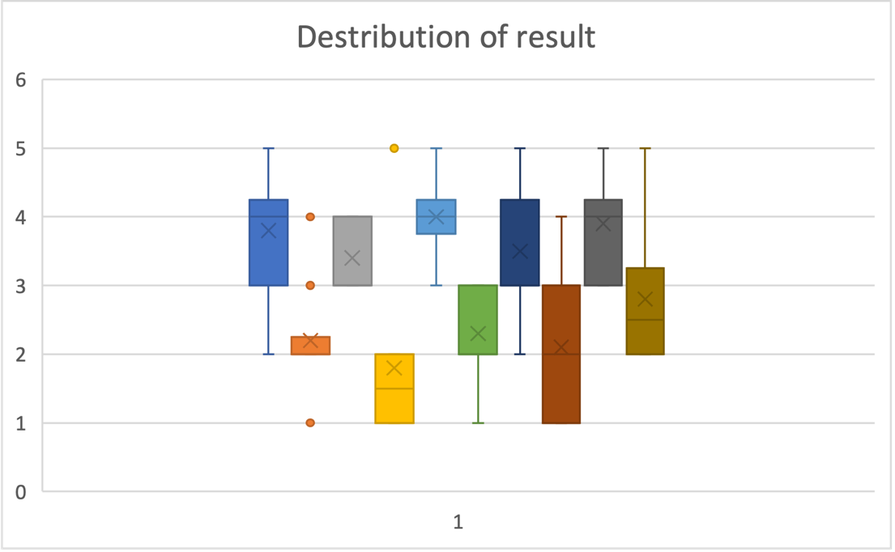

The team created a distribution of the participants' ratings (Figure 25). Looking at the chart, we find that the average SUS score for questions 1 and 7 is significantly lower than that for the other questions.

Question 1 is "I think I would like to use this system frequently". The question is a survey of the user's overall attitude toward the system. The most common answer to this question is 4, which means that users' overall attitude towards the system is at an intermediate or advanced level. As a general question, we still need to analyze the other questions to get the specific problem.

Question 7 is about the usability of the system. To this question, the majority of the answer is 3, which means that most users think the usability of the system is mediocre. Through The detailed interview of some participants on the usability of the system, some users reflected that "The Exercise set your plan is not clear. Should it be set by myself or by the system? Is it weekly? Not easy to understand ", participant 2 thought "Do you set your plan according to your physical condition? Can we change the start date?" "Wendy, and Thomas: Click on the name to appear content, use unclear. What is shown to others and What is not shown to others. ", and participant 3 reflect that, "Wendy Thomas, Intake on it may lead to ____. It's not clear." The lack of usability is due to the "exercise plan" and "Profile" sections.

However, the scores for questions 2 and 3 show that most users expect the system to be easy to use and not complicated, which contradicts the results for question 7. I think the biggest reason is probably a design error that leads to users getting confused about the interaction of some particular pages.

In addition, we can see that the distribution of questions 8 and 10 each has outliers, and participant 10 is the only one who agrees with the situation described in question 8. In a subsequent interview, he suggested that the page that sets up a fitness plan requires a complex operation to set up a personal setting, which is laborious. Another exception to the question was 10. Respondent 6 agreed that there was a lot to learn before they could go and use the system. In question 10, interviewee 6 thought he needed to learn a lot before he could use the system. Because users need to carefully measure some values when creating a fitness plan, there is no specific reference standard for beginners.

Overall, a number of issues were identified that affected the experience of the system, and these issues need to be addressed in the next iteration.

1. **High fidelity prototype evaluation**
   1. **revised conceptual design**

Through the analysis of the intermediate fidelity evaluation, some potential problems affecting the system availability were found. In order to further improve the usability of the system, we will optimize the conceptual design based on the assessment of medium fidelity

* + 1. **System conceptual statement**

The system concept statement remains consistent, as it still reflects the user's overall requirements for the system, based on an assessment of intermediate fidelity.

The overall user attitude towards the usability of the system, as measured by the median fidelity, suggests that the cash problem statement is still useful as a design guide. Users generally feel that today's system is usable and valuable. So, there is no need to modify the problem statement for the time being.

* + 1. **design guideline**

Based on feedback from the intermediate fidelity analysis, some design instructions will be redirected. From previous user feedback, we can see that the lack of further integration of certain features has left many users feeling vague and clunky in the overall design of the system.

Reason for this problem is that in order to meet the "page design is simple and high contrast" design guidelines, system components, use a lot of big size and played down the content of each page, will originally display pages in a divided into multiple pages to display content, leading to a system of dispersing function, causes the feeling of users for system blurred.

Therefore, to solve this problem in the next iteration, we need to balance the minimalist design and functionality. To this end, we have added a new design guideline, "Integrated System Functionality", to reorganize the decentralized system functions and divide the pages to reduce the problem of too many and bulkier pages caused by decentralized system functions. The design guide "Simple and strong contrast page design" has been optimized to "highlight the distribution and components of high contrast color collocation" and "simplify the workflow" to reformat the integrated functionality. In general, the system will divide the different parts of the page through high contrast color collocation. These sections represent different categories of integrated functionality. "Simplifying the workflow" is intended to address the problem of complex interactions that may occur as page functionality increases.

At the same time, another design guideline "Metaphor as Indicators" will be added to help guide the user and help them learn how to interact with the system interface more quickly.

The other design guidelines remain the same because there are no obvious problems with them. These design guidelines will still be used for the next iteration and provide guidance for the design.

* + 1. **system requirements**

The system requirements did not add new system requirements. Based on the assessment results of medium fidelity, the problem mainly lies in the wrong design of the Exercise plan and the features of the profile, which led to poor user experience. Therefore, in terms of the design of the high-fidelity prototype, the system requirements should remain unchanged. The design task of the high-fidelity prototype is mainly to optimize the interaction of the existing features, so as to simplify the process and provide a better interactive experience for users.

* + 1. **high level description**

The high-level description has not changed for the most part, because the requirements for the system have not changed. For this iteration, the high-level description adds a description of the overall design style. Here is the new high-level description.

The system is designed to provide healthy or purpose-specific people with calculations and recommendations of calories burned in exercise and diet.

It will record physical data and targets via a mobile app, giving detailed reports of consumption and intake.

It will allow users the flexibility to choose their workouts or choose from a database of fitness videos, both of which will provide calories burned and record them at any time.

It also offers full fitness recipes and tutorials, as well as the option to count calories by recording the weight of different foods.

It also allows users to post about their fitness routines, and allows users to respond to posts, follow and chat privately.

It will take material design style to reach all the design requirements.

1. **High fidelity prototype description** 
   1. **introduction**

The design style of high-fidelity prototype is taking “material design” as the guide, the advantage is that the feature of “material design” like “high contrast color usage”, “shadow usage” are highly suitable for the design guideline "highlight the distribution and components of high contrast color collocation", and the rich component and the regular design style are most suitable for the design guideline “layout consistency”, “operation consistency” and “reflection consistency”. In the high-fidelity prototype design, we use fixed top navigation bar and bottom bar, component to make the system to reach high level consistency.

**Figure26: high-fidelity prototype overview**

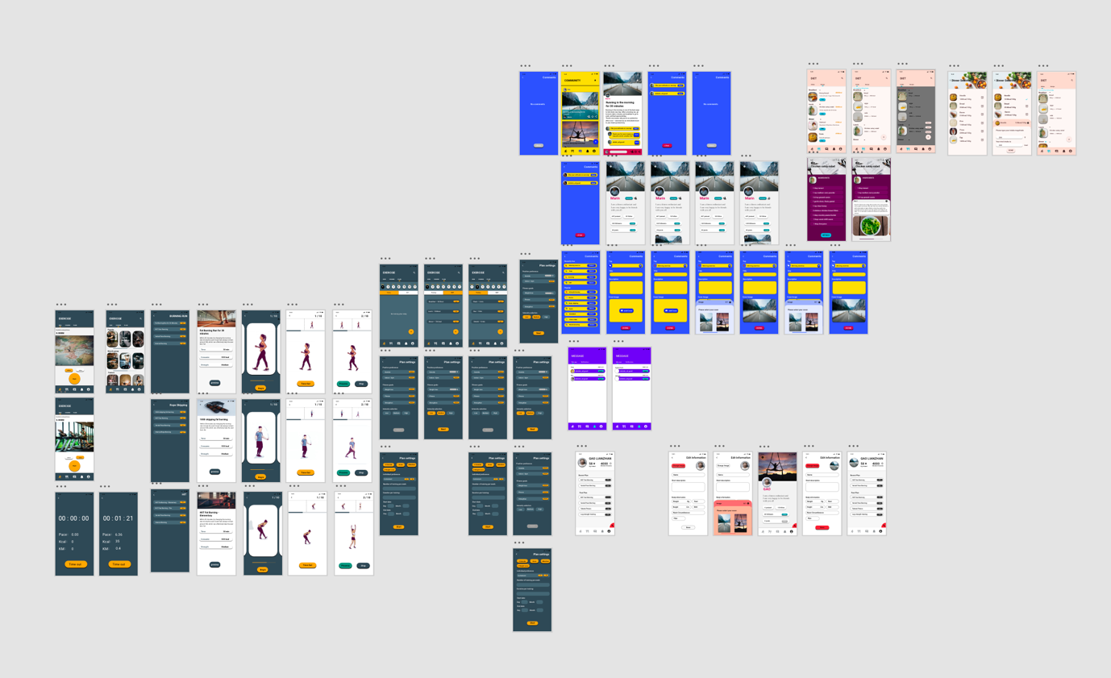

* 1. **Design Style Statement**

The system mainly uses material design style as the design guide.

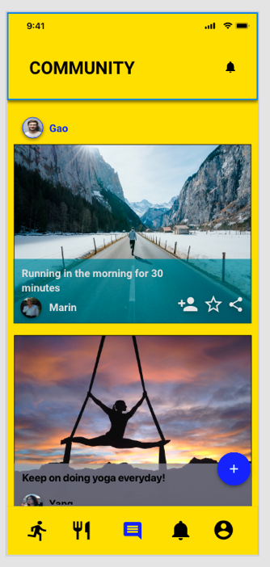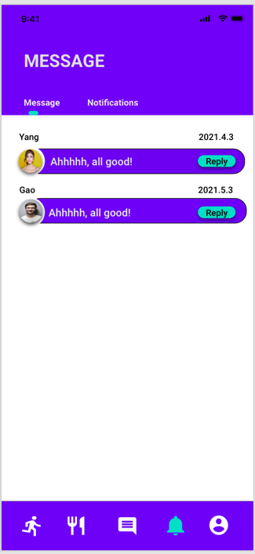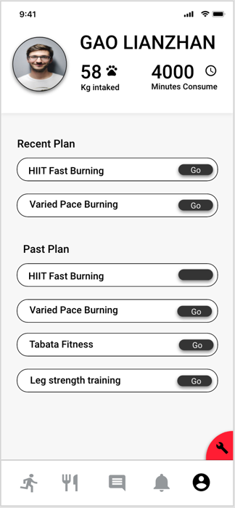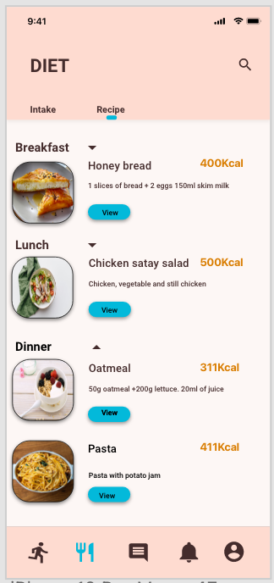

**Figure 27: main pages**

The above is the design of the home page of each part. Through Material Design, we unified the design language of the home page. Each home page will be divided into three parts. For example, on "message", "diet", there is navigation for sub-pages. The sub-pages that are currently on that sub-page are marked and highlighted by "contrast colors" with the top navigation bar color. At the same time, it will also be responsible for displaying some possible global features. For example, on the "Community" home page, we need global features to enable users to quickly view notifications, on the "Diet" home page, we need to quickly display user reports and body data, on the "Diet" page, we need the search bar to take on the task of searching for food.

The bottom is the bottom navigation bar, which, unlike the middle fidelity model, will be the same color as the top navigation bar to increase unity. Its interaction mode has not changed. The top and bottom navigation bars will be shaded to distinguish them from the display area.

The middle area is the display area. For those homepages that need to display less content, the color of the display area is usually like the color of the navigation bar, and the color of the display area is usually lighter, so as to distinguish it from the navigation bar, while taking into account the unity. Also highlight the content that needs to be displayed, such as the display area for "Community" and "Exercise - Plan".

For home pages that display a lot of content, the display area is usually white, because complex content mixed with a bright background prevents users from quickly distinguishing content, such as "exercise -run", "message" and "profile".

The following page is a secondary page that does not belong to the main page and sub-pages. Usually, there is no navigation bar on the secondary page, and only the "back" button and title are displayed at the top. The background color of the secondary page is usually similar to the navigation bar on the main page. The content is usually decorated with a lighter color than the background color of the secondary page to ensure unity. For example, as shown in the Burning Run, the important content of the heavily displayed page is decorated with a "contrast color" with the background color of the secondary page to ensure focus.

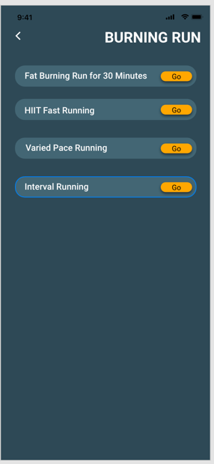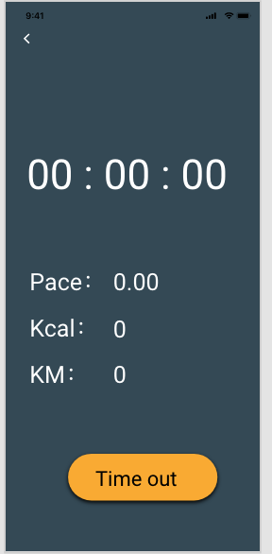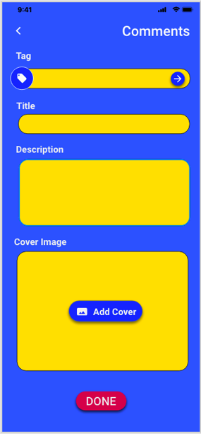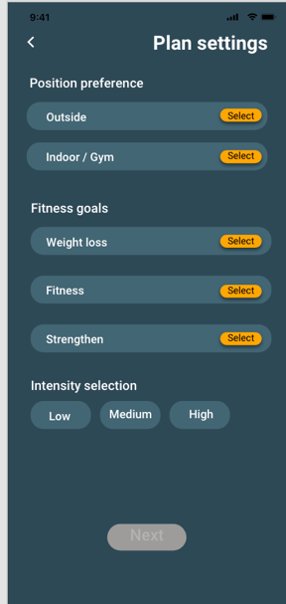

**Figure 29: second-page display 1**

The following pages are sub-pages with images. For these pages, the background color is usually white or light to keep it nice, because the image only takes up a small part of the content, so white is good for showing the content.

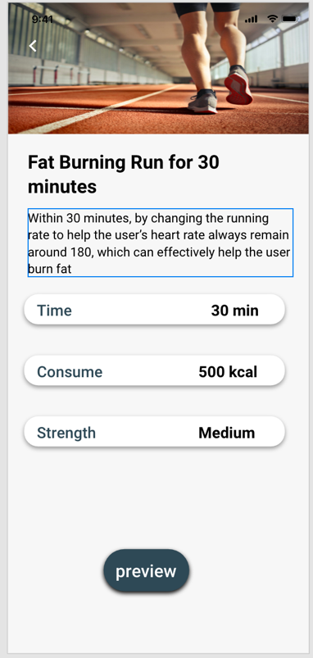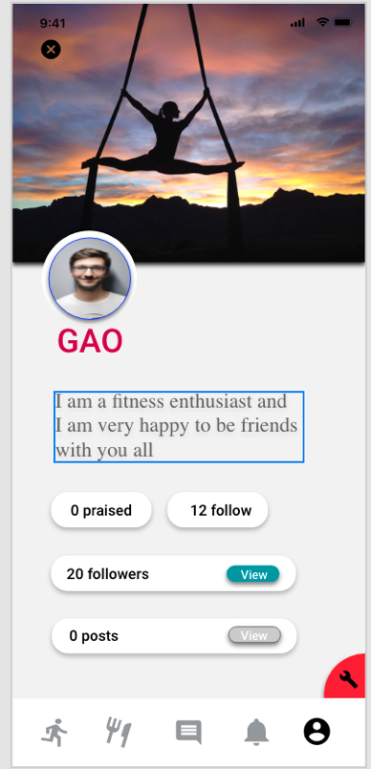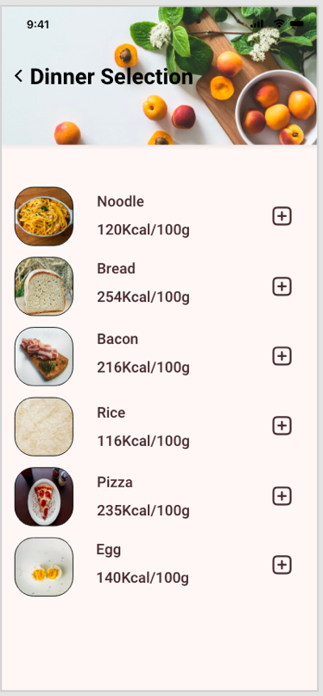

**Figure30: second-page 2**

The following are interactive widgets, which are usually used to display some content and support quick actions, such as quick reply, quick browse and select, as shown in the image below. They have the advantage of being able to integrate the content presentation function and some of the interaction function, and have both aesthetic and system characteristics. This is in line with the design guidance "Integrated System Functionality "and to "highlight the distribution and components of high contrast colour collocation" .

On darker pages, interactive widgets are usually decorated with a lighter colour than the background colour to maintain unity, while on lighter pages, interactive widgets are usually the same colour as the navigation bar, but their "interaction" buttons are decorated with conflicting colours of the navigation bar colours. On white pages, interactive widgets are often shaded to separate them from the white page and improve the texture.

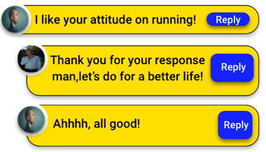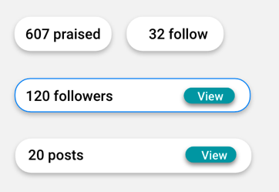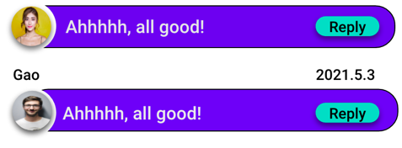

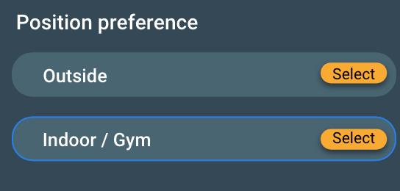

**Figure31: interactive component**

The following are pop-up components. Pop-up components usually exist in "add" operations, such as "add post cover", and "add food", which have two parts, separated by shadows and different light colors. The top section shows the title and the close button, and the bottom section shows the content.

The upper section is usually a lighter representation based on the color of the navigation bar on the page where the component is located, and the lower section is slightly lighter than the upper section for both differentiation and aesthetics.

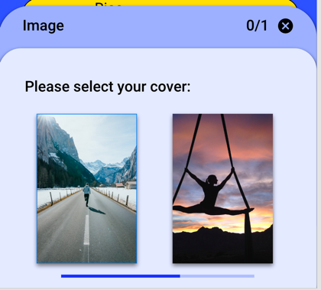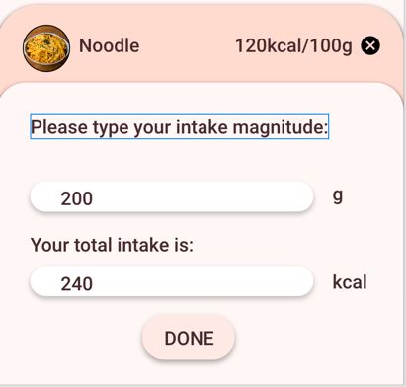

**Figure32: Pop-up component**

Above is the content of the main updates, for some other components description, such as buttons, they were usually depending on the situation and the control's page navigation bar color collision color, said shadows will be modified at the same time, the icon will not be shadow, but according to situation to choose the color of the most prominent, such as shallow icon is usually a black background.

For other updates, I won't go into detail here for space reasons.

*The following link is the full version of the medium-fidelity prototype in Adobe XD*

https://xd.adobe.com/view/f498ec96-d823-46bc-8f20-3d4c1c23dcc7-a1cb/

1. **Hight fidelity prototype evaluation:**
   1. **method**

Heuristic evaluation is used to evaluate the high-fidelity prototype.

* 1. **background**

Heuristic evaluation is a method created by Jakob Nielsen and other colleagues to identify usability issues in a design. Heuristic assessment is a reliable method of design usability assessment that uses a simple, common, and enlightening set of usability rules. This means that some reviewers determine usability issues for the product based on general usability principles and their own experience. The tests showed that each reviewer could identify an average of 35 percent of usability problems over the entire evaluation process, while five reviewers could identify about 75 percent of usability problems.

These usability rules are called Jakob Nielsen's 10 Principles of Interaction Design, Multiple Usability Design. Heuristics are not mutually exclusive and cover many of the same aspects of user interface design. Below is a list of 10 general principles created by Jakob Nielsen.

Known as Jakob Nielsen's 10 Principles of Interaction Design, these usability rules are not mutually exclusive and cover many of the same aspects of user interface design. The table below lists 10 general principles created by Jakob Nielsen.

* 1. **rationale**

One reason for the heuristic assessment approach is that obtaining peer opinion is valuable, because it allows the detection of problem aspects where users will not need to try it. In addition to helping designers focus on a specific problem, heuristics can also help identify usability issues for individual elements and how they affect the overall user experience.

In addition, peer review provides a great deal of qualitative feedback that can be valuable in a redesign, as it shows which parts of the original design can be retained and which parts are more problematic and need to be redesigned.

* 1. **information provided**

Because heuristic is a method based on the subjective opinion of the evaluator. Therefore, heuristic evaluation methods can provide evaluators with reports on usability issues they find in the system. The report will include a description of the usability issues they found, their severity, and the impact on users. In addition, it is possible to generate observation records to record their behavior as they interact with the system to track any problems they encounter.

* 1. **conduction**

The basic idea behind heuristic assessment is to conduct independent assessment prior to collaborative communication.

The first step is to find a group of evaluators, usually people who have their own ideas or experience in design.

On top of this, the evaluator needs to be provided with a set of heuristics, either Nielsen's Top Ten heuristics or some other variant of the rules.

Next, the evaluator will use heuristic principles to discover usability issues with the design, which means that they will be free to interact with the system and find bugs in the process. Often, different evaluators find different problems.

Finally, when they have finished their personal assessment, they will communicate with each other and extract the questions.

* 1. **protocol**

The design of the evaluation plan provides specific guidance for the evaluation process and ensures that the entire evaluation follows a specific process.

The heuristic evaluation protocol consists of three phases. The first phase is the evaluation system that provides information, and the participants need to understand the underlying interactions of the system and other aspects of the design.

The second phase is the evaluation phase, in which reviewers are required to begin reviewing the user system while interacting with the system and to record their findings, the severity of the problem, and any other necessary information they gather based on their observations.

In the final stage, after the evaluators have completed their individual evaluations, they gather together for group evaluations and summaries, and produce a comprehensive report.

* 1. **result and analysis**

In the high-fidelity evaluation, a total of 5 evaluators participated in this evaluation, all of them have relevant design experience and design background, and have their own opinions on the design owner

Five participants completed the evaluation phase of the system independently and discussed their findings together. At the end of the session, they provided a report on the final issues with High Fidelity Prototype, which they all agreed was an important issue for the system. The details of the report are shown in the figure below.

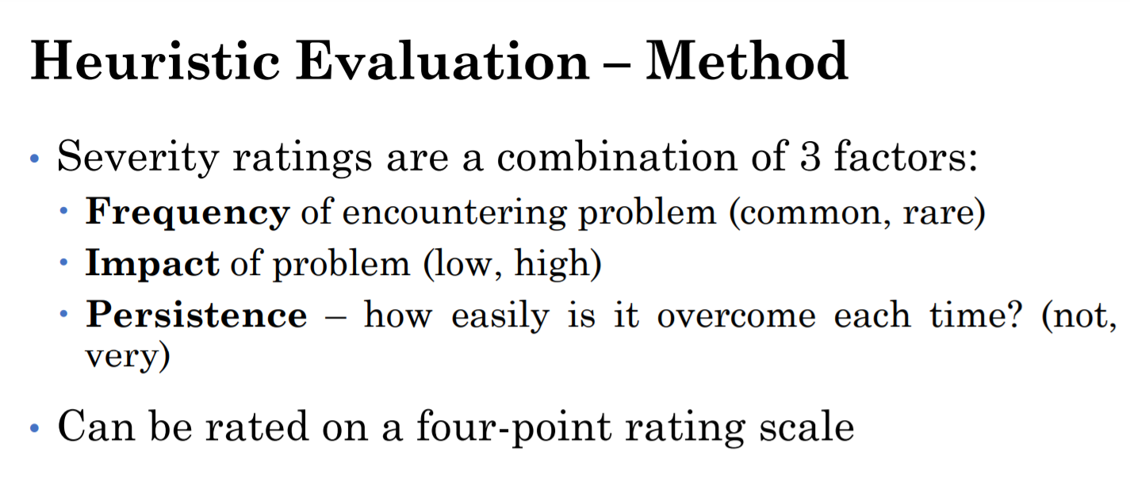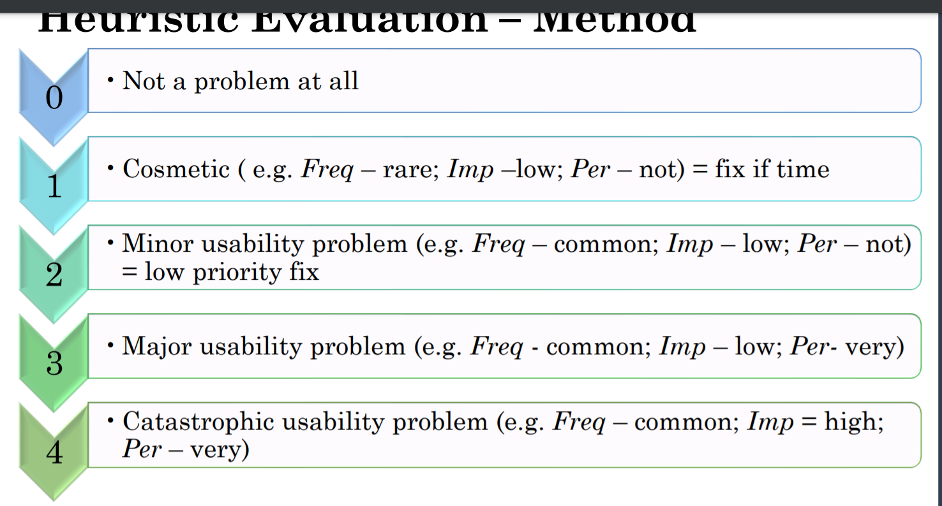

|  |
| --- |
| Visibility of system status |
| Match between system and real world |
| User control and freedom |
| Consistency and standards |
| Error prevention |
| Recognition rather than recall |
| Flexibility and efficiency of use |
| Aesthetic and minimalist design |
| Help users recognize, diagnose, and recover from errors |
| Help and documentation |

|  |  |  |  |  |  |  |  |
| --- | --- | --- | --- | --- | --- | --- | --- |
| Screen/Element Description | Usability Issue | Heuristic Category | Probable effect on user | Freq | Imp | Per | Severity rating |
| Community Home page- There is an excessive ratio of 1 image. | The imagery is taking up too much space. | Aesthetic and minimalist design. | It overwhelms the user, and the user is willing to see more posts in one scroll. | Rare | Low | Very | 0 |
| Community:User page - Replace ‘praised’ text with ICONS | The text doesn't look clear. | Visibility of system status | Can't show the content intuitively. | Common | Low | Very | 3 |
| Community: User page - Followers of another user are not needed to be viewed. | The ‘view’ button to view others’ followers is useless. | Consistency and standards | The users aren’t willing to tap on the button. | Common | Low | Not | 2 |
| Community:User page - Expand posts part | The Collapsed ‘posts’ part of the user is useless. | Flexibility and efficiency of use | Increase user operation time. | Common | Low | Not | 2 |
| Community: Home - User Icon placed to top. | The user icon shall be placed above the community banner at the top of the page. | Aesthetic and minimalist design. | Users are willing to know what account they are viewing from and would like their icon to stand out more. | Rare | Low | Very | 0 |

In general, the community’s page suffers from only one major usability issue which is to replace praised text on the user’s page with an icon. This would allow the button to be more straight-forward and intuitive rather than an uncommon word. Some minor issues were the useless existence of the view button in the user page. The user suggests that it would be more convenient and consistent to show their posts straight away rather than needing the user to press the view button to view. It would much decrease the willingness of the user to view the posts. Also, the view button to view others’ followers isn't necessary since many users won’t be interested in exploring others’ followers. Other suggestions given were not really an issue, where it’s leaning more towards personal preferences.

|  |  |  |  |  |  |  |  |
| --- | --- | --- | --- | --- | --- | --- | --- |
| Screen/Element Description | Usability Issue | Heuristic Category | Probable effect on user | Freq | Imo | Per | Severity rating |
| Run page:new way to test consume Kcal | The method of testing the consumption of Kcal is not accurate. | Flexibility and efficiency of use | Let users misestimate exercise time. | Common | Low | very | 3 |
| Exercise course page: Share link | Add a shared link to the course page. | User control and freedom | Users cannot share the results after finishing the exercise course. | Common | Low | Very | 3 |
| Exercise: Lessons page - Narrow bars and no use of images. | The bars outlining the lessons are too narrow. The lessons shall have an image as a brief introduction. | Aesthetic and minimalist design | Hard for users to tap on the desired buttons. Users cannot see the activity intuitively. | Common | Low | Not | 2 |
| Run page - A record of the past history of running. | A record of the past history of the running performed shall be produced. | Flexibility and efficiency of use | The users aren’t able to keep track of the running they have completed in the past. | Common | Low | Not | 2 |

There were two major issues identified within the exercise sector being an inaccurate estimation of calories consumption. This would affect the user as they cannot accurately set an exercise time frame for their desired calories consumption. Another issue was a user control issue where they aren’t able to share their completion of an exercise to others. It was suggested to have a direct sharing pathway from the exercise sector to the community. There were also two minor issues picked up by the users was that mainly in exercise, also in other pages, the framing of content is very narrow, which results in the user mis-tapping the desired location causing the users not being able to enter other pages. The other issue was that users are also willing to have a record of the past history of their running to remind them of the exercises they have already been completing. This was suggested as users aren’t able to keep track of all the running they have completed in the past, but still, they would like to summarize and set their plans, and the past performance becomes important.

|  |  |  |  |  |  |  |  |
| --- | --- | --- | --- | --- | --- | --- | --- |
| Screen/Element Description | Usability Issue | Heuristic Category | Probable effect on user | Freq | Imo | Per | Severity rating |
| Diet - Intake Magnitude | Complication of measuring the intake amount of food | User control and freedom | The user doesn’t have as much time to detail everything all the time. | Common | Low | Very | 3 |
| Diet - Intake Text is too small | The text is too small ‘You can still eat xxx kCal today’. | Aesthetic and minimalist design | The user might not be aware of the warning text and may over consume | Common | Low | Very | 3 |

There were two major problems in the Diet sector, the first issue was that the measurements of the intake magnitudes are very time consuming. It is very difficult to cap all consumption to grams, for example, how would liquid be measured? As well as not all users has the time to measure the weight of the food they are consuming prior to processing. The other issue is that the warning text ‘You can still eat xxx kCal today’ is in a small font size, users might not be aware of the text and may over consume which would impact their desired exercise outcome.

|  |  |  |  |  |  |  |  |
| --- | --- | --- | --- | --- | --- | --- | --- |
| Screen/Element Description | Usability Issue | Heuristic Category | Probable effect on user | Freq | Imo | Per | Severity rating |
| Personal home page-change icon behind weight. | The text doesn't look well. (dog’s palm icon) | Visibility of system status | Icons don't make sense and are confusing. | Common | Low | Very | 3 |
| Personal home page - change personal page | The page looks too simple. | Consistency and standards | The user feels awkward about this page. | Common | Low | Not | 2 |

There were also two issues for the personal profile page, the first issue is that there are unnecessary dog’s palms next to the figure. It was depicted by the user that there are no behind meanings for a dog’s palm resulting in the existence of the icon being confusing. Another issue is that the page looks too simple, it seems to be a wireframe with functions instead of a high-fidelity prototype. More functions could be added, or else, define the parts into more details so that the page doesn't seem as simple.

|  |  |  |  |  |  |  |  |
| --- | --- | --- | --- | --- | --- | --- | --- |
| Screen/Element Description | Usability Issue | Heuristic Category | Probable effect on user | Freq | Imo | Per | Severity rating |
| App page: Change and unify page colors. | Pages have high color saturation and are not uniformly colored. | Consistency and standards | High saturation pages can feel tired after a long time. | Rare | Low | Not | 1 |
| Profile page: The Go buttons shall be replaced with arrowheads. | The ‘GO’ button is a little unnecessary. | Consistency and standards | It’s very repetitive to see the same word on the page many times. | Rare | Low | Very | 0 |

The identified issues in general were cosmetic issues, the colour of the application needing to be more unified and lighter. The full saturation of the background with high comparison causes aesthetic fatigue which disagrees with the purpose of the application of creating a smooth atmosphere. This could be fixed by an alternation of colours and decreasing the contrast of the colours. The other suggested problem was ranked low on severity rating, therefore it will not need to be fixed immediately.

Overall conclusion:

After three iterations, the system has changed dramatically in appearance and function, but it still has a long way to go to perfect design, and if we can continue to study and iterate, I believe it will become more successful as the design gets closer.

Through this project, I learned how to effectively evaluate a design, conducted a purposeful investigation in the early stage of design, including some design theories that affect the design quality, and had a deep understanding of the whole project evaluation process.

Appendix:

Appendix 1 – low fidelity prototype

|  |  |
| --- | --- |
| Evaluation ID | 01 – low fidelity prototype test |
| Purposes | Test the performance and function of low fidelity prototype, get development ideas of medium fidelity prototype. |
| Test media | Zoom meeting demonstration / realistic manipulation |
| Date | 24 April 2021 |
| Presenter | Lianzhan Gao, Yi Yang |

* 1. **Preparation before the task:**

1. Participant information sheets
2. Participant task recording sheets – record the interaction taken with timestamp in process
3. Task sheets – assistant sheet that help participants interaction with system
4. Questionnaire spreadsheet – TAM questionnaires
5. Pencil and paper sheets – for realistic manipulation
6. Zoom meeting room generation – for remote demonstration
7. Zoom link invitation – for remote demonstration
   1. **Task process:**
      1. Flow:

* Introduction
* Send participants information sheets and make sure every participant fill in.
* Make sure the prototype is ready to be tested.
* Contribute task sheets and make sure everyone has same content.
* Begin the task.
  + 1. Begin:

Hello everyone, I am happy that everyone come and give feedback for our current system. Today, you guys need to interaction and experience with our system to finish tasks.

I hope everyone can show your feeling about your usage of our system, such as whether the system is easy to be used, whether the system can help for your purpose, and whether it is easy to interact with system.

In the task, we will not interfere you in the process, you can keep your rhythm when experience. All our expectation is your reflections.

* + 1. Participant information sheets intro:

You guys should finish this participant information sheets, it tells you the aim of the task you will take today and where that data will be used.

[participants finish read]

[participants fill in sheets]

Alright, thanks everyone fill in the sheet and believe us. Now, let’s begin.

* + 1. Task Process:

This task is the interaction task, we hope you guys can follow the interaction scenarios to finish system business to experience important features we developed. You will have 15-20 mins to explore and work with system. Again, we will not interfere or lead you guys with some preferences, you are free to follow the interaction scenario instructions below and do you work.

So, does anyone have some questions about this task?

[no questions]

[show/distribute task sheets]

* + 1. presenter division of work

|  |  |  |
| --- | --- | --- |
| Role | Name | Work |
| Main presenter | Lianzhan Gao | Hint how to use the prototype, explain questions and tasks, and control the rhythm of whole process, ask follow-up questions |
| Process recorder | Yi Yang | Record actions that each participant did |
| Timestamp recorder | Yi Yang | Record the time consuming each participant finished their works |

* + 1. Interaction Task steps

1. Type your personal data and create your own exercise plan.
2. Type your diet and exercise behaviors and get your own diet and exercise course recommendations.
3. Create your regularly exercise consuming report.
4. Find and get your daily calories consuming report.

As the task sheets shows, today you guys need to finish these tasks.

[read tasks]

* + 1. Task Details by presenter

1. Type your personal data and create your own exercise plan.

* Record the time taken that participants find the enter approach in Home Page
* Take notes on how participants type their data
* Observe whether participants are satisfied for generated exercise plan.

1. Type your diet and exercise behaviors and get your own diet and exercise course

recommendations.

* Pay attention to the timestamp the process that user go through from Home Page to Exercise Page
* Take notes on whether participants are satisfied for recommendation

1. Create your regularly exercise consuming report.

* Observe steps that user set up the report
* Record how participants find the correct user interface

1. Find and get your daily calories consuming report.

* Record whether participants are satisfied for the calorie calculation.
* Pay attention to how participants add diets and exercises and calculate new consumption value.
  1. **Questionnaire process**
     1. Flow:
* Contribute questionnaire sheets to all participants after they finish the interaction tasks
* Make sure the content in questionnaire sheets of every participants is same.
* Start rate questions
* Ask follow-up interviews
* close
  + 1. Begin / transition

In the next stage, I will ask all of you to finish our research questionnaires by filling in this questionnaire spreadsheet. It contains survey questions about your using experiences and you need to rate them from 1 to 4. 1 means strongly disagree and 4 means strongly agree.

Here are our questionnaires.

[spread questionnaire spreadsheets]

* + 1. Questionnaires

Dimension factors intro:

* PU – perceived usefulness of system
* IMG – image
* EXP – user experience
* SN– subjective norm
* OQ – output quality
* PEOU – perceived ease of use
* BI – behavior intention

Spreadsheet:

|  |  |
| --- | --- |
| Dimension | Question |
| PU/IMG1 | I believe that this app can improve my body shape. |
| PU/IMG2 | I believe that this app can increase my social image and attraction. |
| PU/IMG3 | I believe that this app can help me on healthy food intake. |
| PU/EXP1 | I agree that this app can help me finish my health goals. |
| PU/EXP2 | I agree that my work is efficient when I am using this app |
| PU/SN1 | I think this app have good prospects and I will use and introduce it to my friends. |
| PU/SN2 | I agree that this app can give me help with my health keep, even the later design style is not satisfied. |
| PU/OQ1 | I agree that this app can increase my life quality in diet and health. |
| PU/OQ2 | I agree that I will avoid mistakes in the way of exercise as well as diet when I use this app. |
| PEOU1 | I agree that I can easily understand the UI when I first interact with it. |
| PEOU2 | I agree that I can easily find needed function in an interface. |
| PEOU3 | I agree that the exercise consuming report is suitable for me. |
| PEOU4 | I agree that the recommendation is help for my goals |
| BI1 | I will always use this app in my life. |

Questionnaire data collection:

* Put rate data into extended spreadsheet.
* Calculate average with benchmark set up, calculate median and mode
* Generate relevant charts and diagram
* Construct follow up interviews

Closing:

All right that’s all the task you need to do today, thanks everyone can join our evaluation meeting today, I am very appreciate with your patients and responses. Have a good time!

* 1. **TAM data evaluation**
     1. Respond spreadsheet

|  |  |  |  |  |  |  |  |  |  |
| --- | --- | --- | --- | --- | --- | --- | --- | --- | --- |
| Dimension | Questions | RP1 | RP2 | RP3 | RP4 | RP5 | RP6 | RP7 | RP8 |
| PU/PUR1 | I believe that this app can improve my body shape. | 2 | 2 | 2 | 2 | 3 | 1 | 2 | 3 |
| PU/PUR2 | I believe that this app can increase my social image and attraction. | 2 | 3 | 3 | 3 | 3 | 2 | 3 | 3 |
| PU/PUR3 | I believe that this app can help me on healthy food intake. | 2 | 1 | 3 | 1 | 2 | 2 | 3 | 2 |
| PU/UX1 | I agree that this app can help me finish my health goals. | 3 | 2 | 3 | 3 | 2 | 1 | 3 | 3 |
| PU/UX2 | I agree that my work is efficient when I am using this app | 2 | 1 | 2 | 3 | 2 | 2 | 1 | 2 |
| PU/SN1 | I think this app have good prospects and I will use and introduce it to my friends. | 2 | 2 | 3 | 2 | 3 | 1 | 2 | 3 |
| PU/SN2 | I agree that this app can give me help with my health keep, even the later design style is not satisfied. | 2 | 1 | 2 | 1 | 3 | 1 | 2 | 3 |
| PU/BO1 | I agree that this app can increase my life quality in diet and health. | 1 | 2 | 2 | 1 | 2 | 2 | 1 | 2 |
| PU/BO2 | I agree that I will avoid mistakes in the way of exercise as well as diet when I use this app. | 2 | 3 | 3 | 3 | 2 | 2 | 3 | 3 |
| PEOU1 | I agree that I can easily understand the UI when I first interact with it. | 3 | 3 | 3 | 3 | 4 | 3 | 4 | 3 |
| PEOU2 | I agree that I can easily find needed function in an interface. | 4 | 3 | 4 | 4 | 4 | 3 | 4 | 4 |
| PEOU3 | I agree that the exercise consuming report is suitable for me. | 4 | 4 | 3 | 3 | 2 | 3 | 4 | 4 |
| PEOU4 | I agree that the recommendation is help for my goals | 2 | 3 | 3 | 2 | 2 | 3 | 4 | 3 |
| BI | I will always use this app in my life. | 2 | 2 | 2 | 3 | 2 | 3 | 3 | 2 |

* + 1. Average rate for each response

|  |  |  |  |  |  |  |  |  |
| --- | --- | --- | --- | --- | --- | --- | --- | --- |
| Response | RP1 | RP2 | RP3 | RP4 | RP5 | RP6 | RP7 | RP8 |
| Average Rate | 2.36 | 2.29 | 2.7 | 2.43 | 2.57 | 2.07 | 2.79 | 2.86 |

* + 1. Average, median, mode and benchmark for each dimension:

Benchmark for each dimension

Table1 Benchmark for sub dimension

|  |  |  |  |
| --- | --- | --- | --- |
| Sub-dimension | mean | median | mode |
| PU/PUR | 2.5 | Null | Null |
| PU/UX | 2.2 | Null | Null |
| PU/SN | 2.4 | Null | Null |
| PU/BO | 2.3 | Null | Null |

Table2 Benchmark for dimension

|  |  |  |  |
| --- | --- | --- | --- |
| dimension | mean | median | mode |
| PU | 2.25 | Null | Null |
| PEOU | 2.5 | Null | Null |
| BI | 2 | Null | Null |

Table 3 Rate in the form mean, median and mode for sub dimension

|  |  |  |  |
| --- | --- | --- | --- |
| Sub-dimension | mean | median | mode |
| PU/PUR | 2.292 | 2 | 2 |
| PU/UX | 2.1875 | 2 | 2 |
| PU/SN | 2.0625 | 2 | 2 |
| PU/BO | 2.125 | 2 | 2 |

Table 4 Rate in the form mean, median and mode for dimension

|  |  |  |  |
| --- | --- | --- | --- |
| dimension | mean | median | mode |
| PU | 2.18 | 2 | 2 |
| PEOU | 3.28 | 3 | 3 |
| BI | 2.375 | 2 | 2 |
|  |  |  |  |

Appendix 2—SUS protocol

Results:

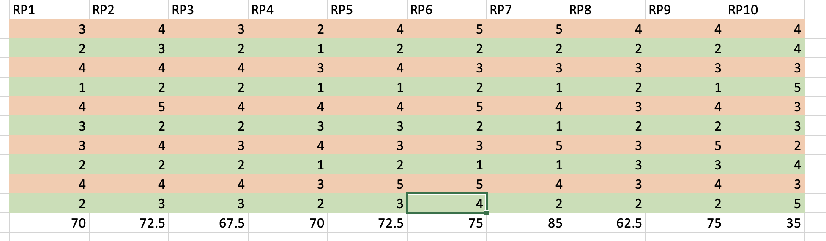

Transcript:

INTERVIEWEE1:

1: No Log In page.

2: community: font optimization, post page, text outside the dialog box.

3: Exercise's Run page links to the watch.

(Mainly how to record running track and expenditure)

4: Pictures should be added to the Exercise course page

5: The Exercise set your plan is not clear. Should it be set by myself or by the system?

Is it weekly?

Not easy to understand.

6: The icon of the DIET page should be added

Change the font and size

8: Diet: Better to add delete function

9: DIET: RECIPE METHOD can't be clicked

10: DIET: RECIPE tutorial section, it's better to add video tutorial, give a variety of options.

INTERVIEWEE2:

1: COMMUNITY: replace tag pattern to icon

2: EXERCISE: Do you SET YOUR PLAN according to YOUR physical condition?

Can we change the start date?

3: Diet: Ingrefients AND Method content is clear, now a bit like PPT

4:Keep a calendar of what you eat each day.

(message records)

5:See if we can add other users' DIET plans?

6: Profile: Wendy Thomas: Click on the name to appear content, use unclear

What is shown to others and what is not shown to others.

8. Is the plan generated according to the recorded body data?

INTERVIEWEE3:

1: the page is a little general, simple.

It's not very clear what the parts are

2: Wendy Thomas, clicking on it may lead to misunderstanding.

It's not clear.

3: Diet: Add detailed pictures to the page.

4: Log in page?

5. Is it necessary to register the body data during the process of clicking the software?

6: Click on the detailed explanation after the course, the course page?

Appendix 3 – heuiristic result

Transcript:

RAW DATA

COMMUNITY:

1: The page icon of each PO text is too big, about three are about the same

2: Replace thumb up logo with finger icon

3: Followers do not need a view. Do not want to see what Followers this person has

4: Post is not folded. It is hard to see clearly and the button of View is small and hard to click

5: The user's own icon is placed at the top

EXERCISE:

1: Run speed is not clear and Kcal consumption is not clear.

2: Fitness movements can be extended to the community to complete a course can be directly sent to the community

3: There are too many rules and can be a little wider fitness course category click into the course options page can be attached with pictures

4: Record can be added for running.

DIET:

1: How accurate is food down to g? Weighing is too troublesome,

2: food restrictions can be a little conspicuous font is a little small if you don't pay attention to it easily overeat

PROFILE:

1: The weight part of the dog's paw icon has been changed

2: The page is too simple

GENERAL:

1: the page color saturation is high, uncomfortable to see for a long time, blue and yellow color ratio is not good

2: It is best to change the button of Go to the arrow

Appendix 4 – low fidelity prototype mindmap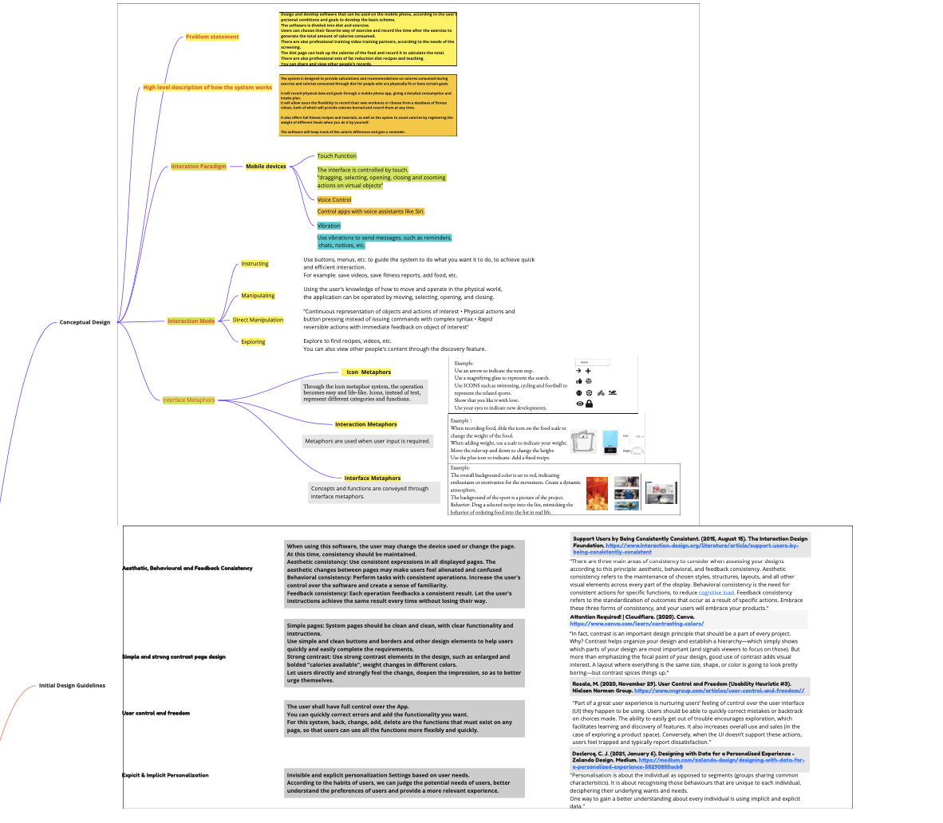

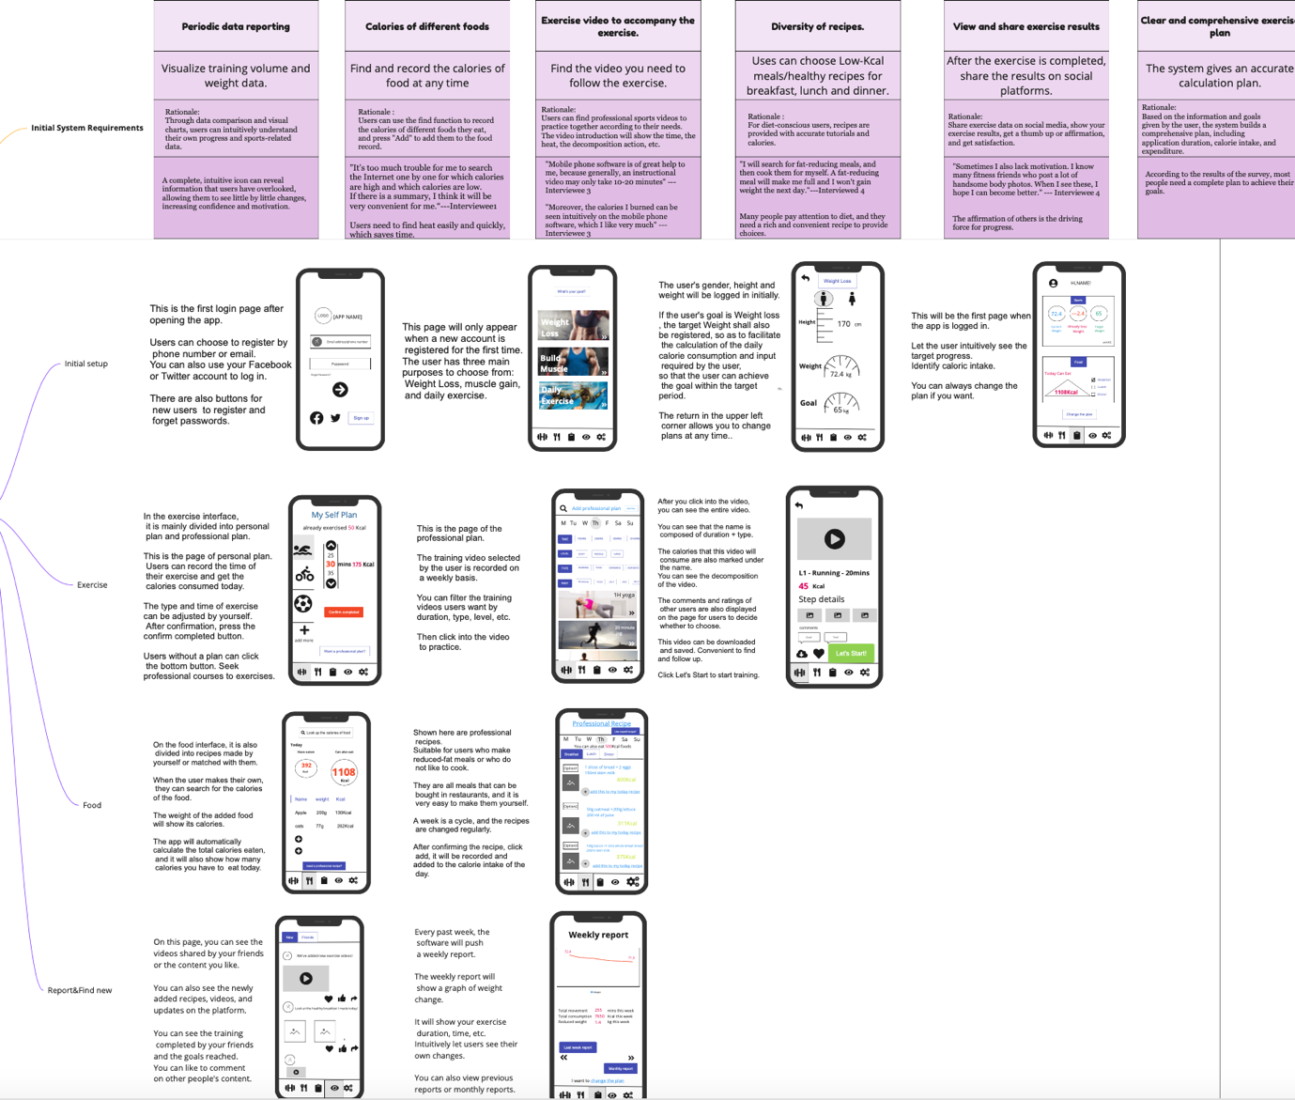

Appendix 5—interview and survey result

SURVEY RESULT：

questions 1 - 3 : These three questions can help us identify target groups.

question 4 : the purpose of using the application.

question 5-8: To collect some feedback from respondents on the interface from the existing interface. (low flexible prototype)

question 9-18: Gather views and requirements for existing features.

question 19-21:Other needs.

1. What is your gender?

1. What is your age?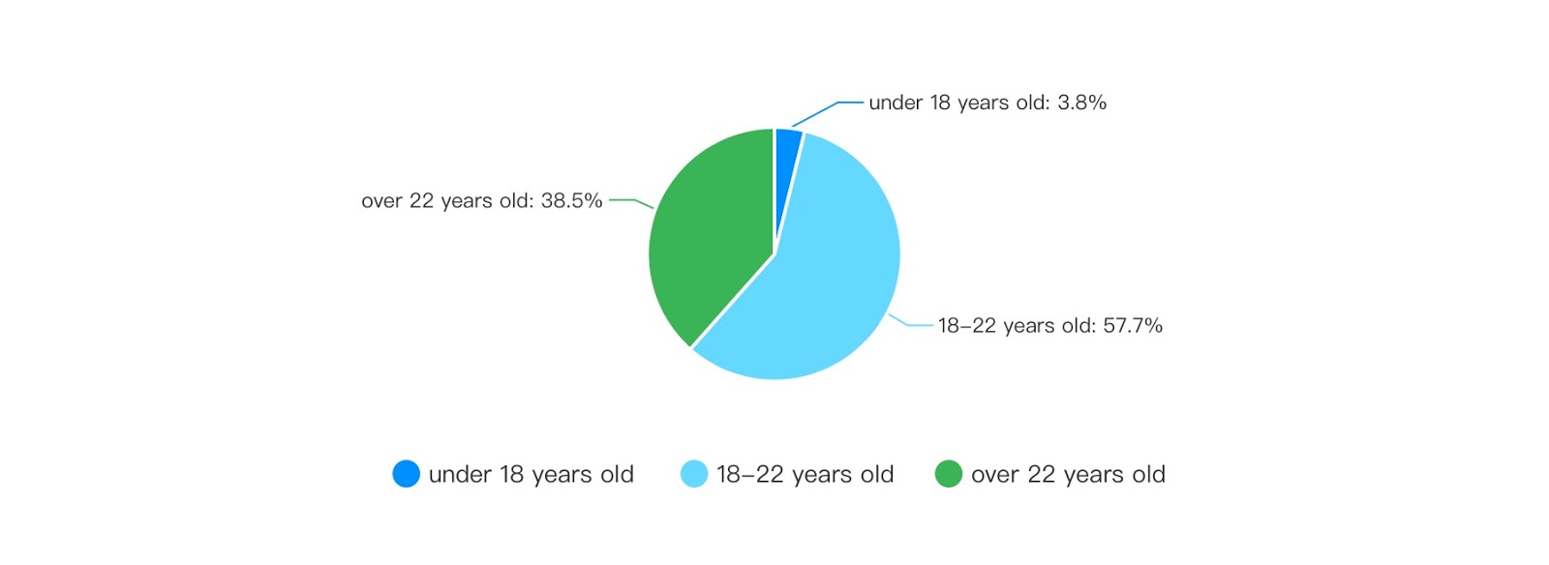
2. What is your occupation?
3. What is your purpose to use fitness app?(main reason)
4. keep healthy
5. keep fit
6. lose weight
7. The usefulness of fitness application tools depends on the purpose of the user. Generally: 1. Fitness literacy; 2. Save time; 3. Self-management; 4. Cultivate exercise habits; 5. Satisfy social interaction
8. Assist me in postural learning and correction.

1. According to these part of interface page, please rate how strongly you agree with the following statement: I think you can use this app easily without guidance, and know the general purpose of each icon.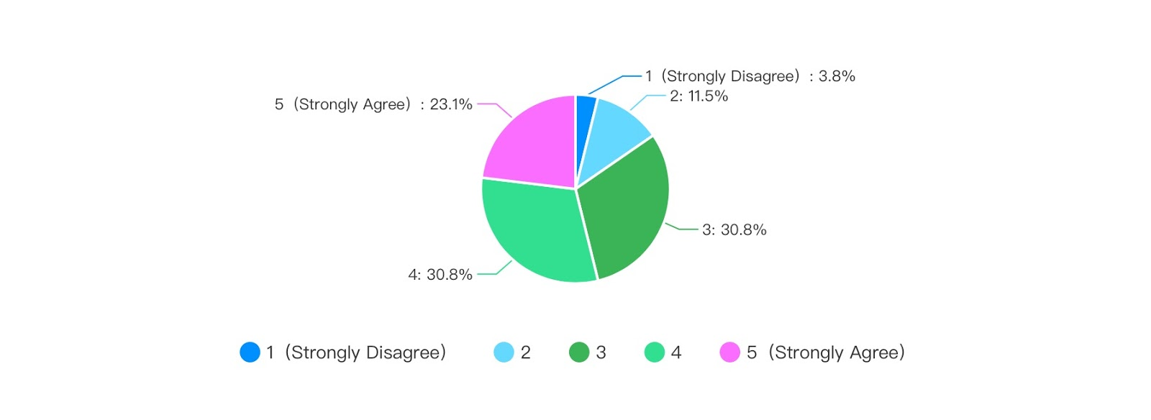
2. According to these part of interface page, please rate how strongly you agree with the following statement: These frames and colors look comfortable and simple.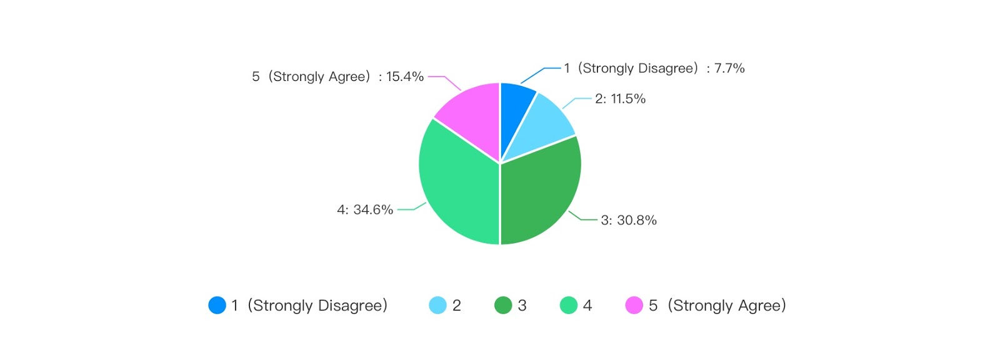
3. According to these part of interface page, please rate how strongly you agree with the following statement: The text used on the interface looks comfortable.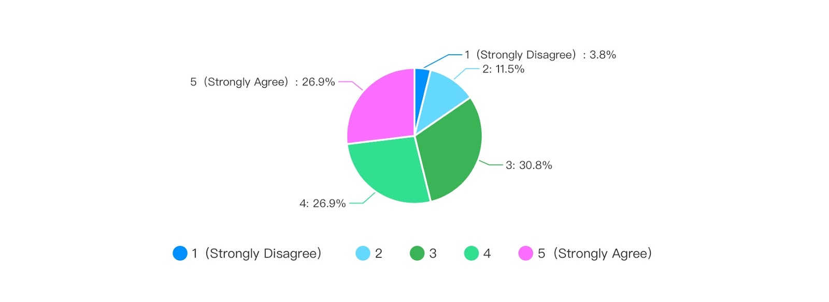
4. In style of component combination, do you think such a layout feels comfortable? Are these layouts suitable as a fitness app? Do you have any suggestions for this?
5. It looks too crowded in a single page，I think you should keep some space blank at least.
6. I’m sorry that I don’t particularly like the design style of this software. I personally think that whether an app can meet the public’s aesthetic is important.
7. UI is a bit complex
8. the app should add a front
9. Use similar colours for icons
10. The layout of each page is not uniform enough. Every page is very different, and that's not good. You'd better follow the consistency principle for the interface.
11. Some pictures have been distorted.
12. It looks too crowded in a single page，I think you should keep some space blank at least.
13. I felt the second page was a bit messy, maybe the spacing wasn't particularly well done, like all the features were rubbed together.

1. For existing apps, what do you think are the shortcomings of their functions?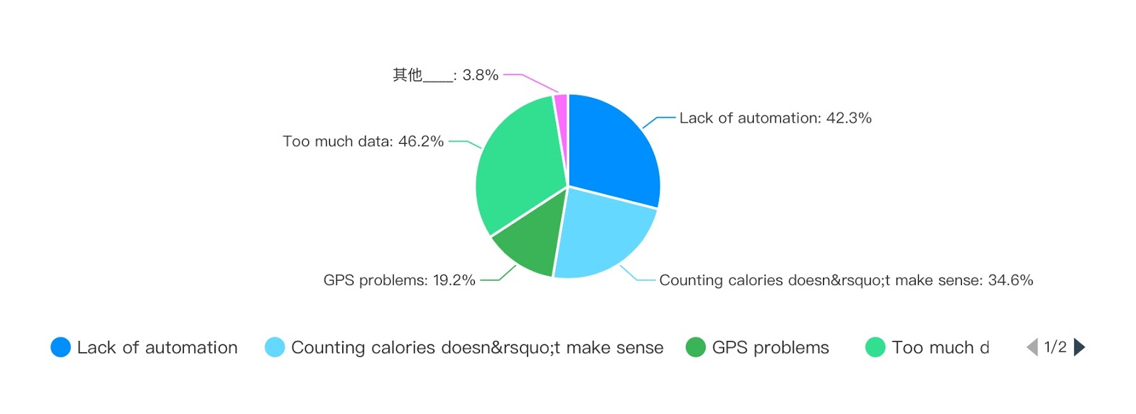
2. Do you know that if you don't have regular exercises, it will cause harm to your body?
3. please rate how strongly you agree with the following statement: Fitness (lose weight) can bring me a better quality of life.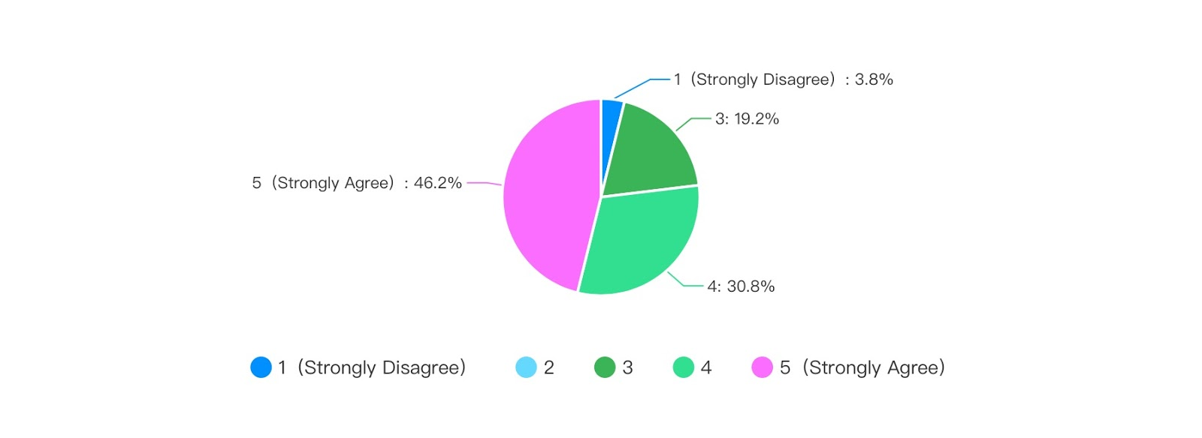
4. please rate how strongly you agree with the following statement: This calorie calculation function can help us to reduce fat better.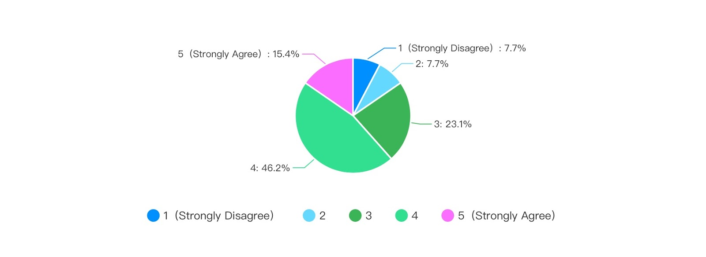
5. For the calorie calculation function, the use of QR technology can more conveniently record the calories the user consumes per meal.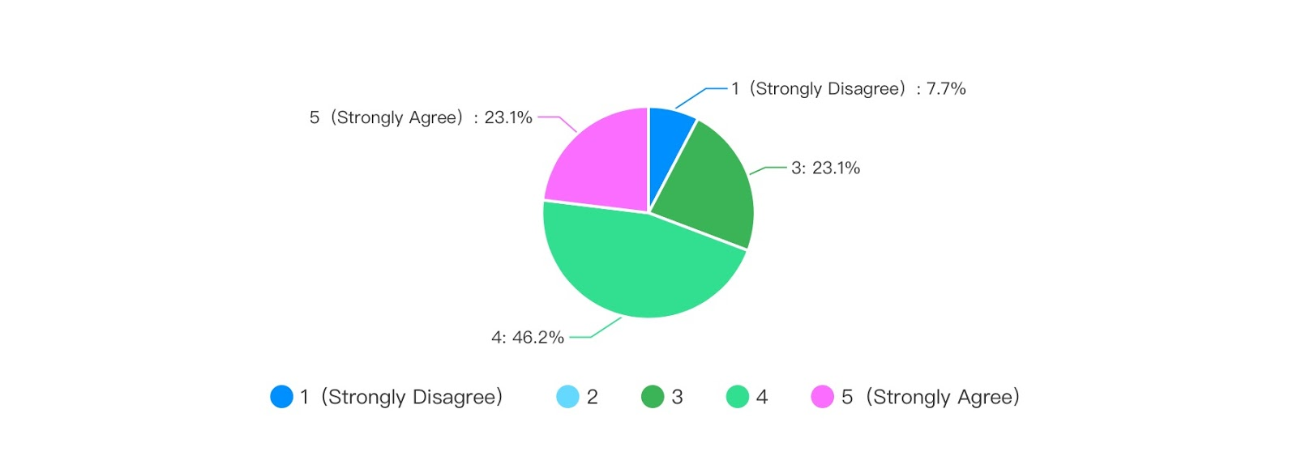
6. please rate how strongly you agree with the following statement: Virtual communities can help users communicate with each other, and on the other hand, it can urge them.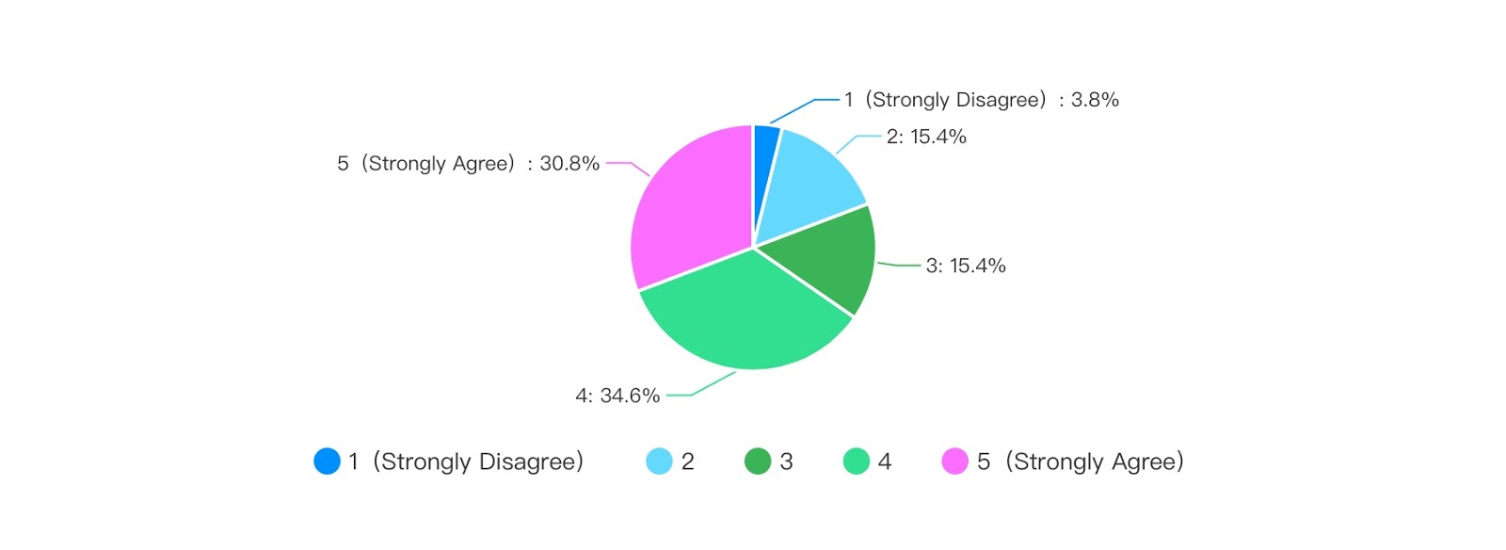
7. please rate how strongly you agree with the following statement: Weekly reports can better help users know how much they have lost and increase their self-confidence.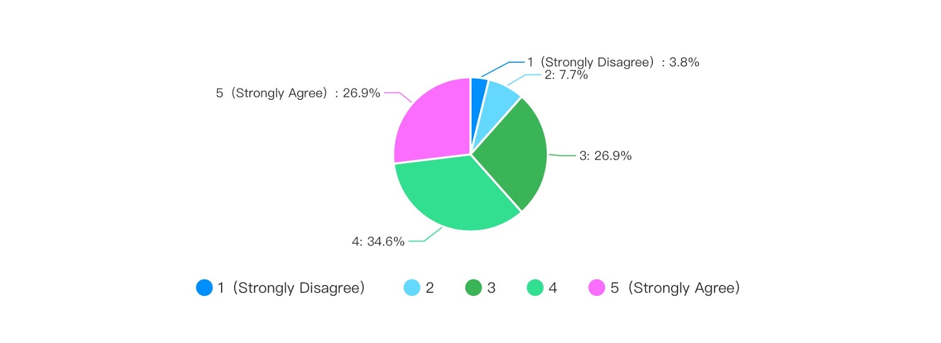
8. please rate how strongly you agree with the following statement: Training courses can help users better achieve their fitness goals. And it is convenient for users to find a method that suits them.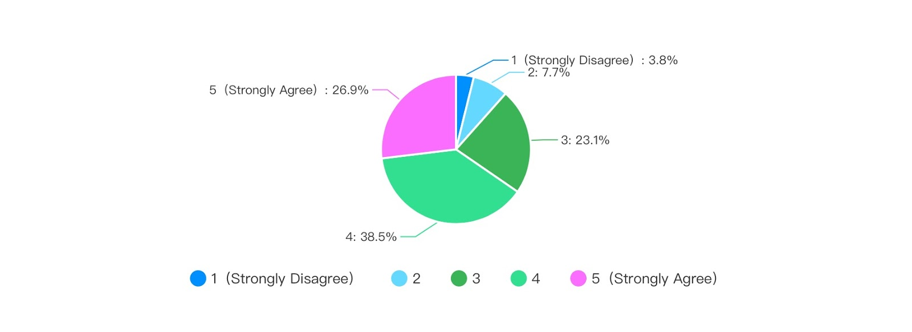
9. Would you like to application sell prepared reduced-fat foods?
10. What function do you think this application needs to make it more perfect?
11. Record weight and have a data comparison
12. I think we can add a friend function, add nearby friends who want to work out together, and then exercise together, such as getting up for a run in the morning.
13. ui
14. monitor
15. It's not just weight loss, some people need to gain weight and muscle, need corresponding assistance, preferably to monitor body fat rate.
16. It's hard to use an app while exercising, no matter running of lifting weights
17. Maybe fitness music
18. set a goal
19. courses
20. interface design

1. The virtual community function allows users to communicate, whether you are worried about being deceived.
2. Are you worried about your personal information being leaked？
3. After you use this app, would you recommend this app to others?

INTERVIEW RESULT:

1. Your age, gender, occupation.
2. Female, 19 years old, student.
3. Male, 28, IT technician.
4. Female, 31, sales.
5. 20 male students.
6. l am a 19 years old female university student.
7. l am a 20 years old male, student of UQ.
8. Age: 21 Sex: Male Occupation: Student.
9. 32, male, civil servant.
10. 20 female student.
11. 19, female, student.

1. Why do you use fitness software?
2. To lose weight.
3. For fitness, increase muscles and maintain health.
4. Mainly to increase muscle and reduce fat.
5. Weight loss (fat reduction)
6. l want to use a fitness app to get a healthier body and good body shape
7. l usually use fitness applications for lost weight and keep good body shape.
8. Save time, friend's recommendation, and self-understanding.
9. By chance, I was walking with my friend and talked about fitness. I heard that my friend said that I was using fitness software. I also chose to use fitness software for more scientific exercise.
10. I want to be in shape, I don’t get fat, but I look fat because I don’t exercise
11. I am too fat and want to lose weight. Purposeful stovepipe

1. What fitness software have you used? What aspects of it attracted you?
2. BetterMe Keep, Mint. BetterMe is because there is a countdown to control your diet, you can see how long you haven't eaten. Keep is because you can follow the exercise video above to exercise. , Mint has recipes and food calories on it.
3. WeChat steps. I don't like to use fitness software, because I usually go to the gym. The atmosphere in the gym is better, and there are professional coaches to communicate at any time.
4. Mint, keep, Betterme, Fire...mainly convenient and fast, you can exercise in your spare time. Control your diet and record how much you eat every day.
5. keep. Record the calories burned and many training sessions
6. I usually using Nike Run Club and Nike Training Club, since the interface design of these two apps is comfortable, the animation is just right and attractive. For Nike Training Club, its sports lessons are very detailed and I can easily follow the training,  I can also make a plan according to my own conditions and the purpose of the exercise. l really like the voice coach in Nike Run Club, it is flexible and scientific.
7. l used Keep, Fit, and Nike Training Club, but l usually use keep. The reason why l using Nike Training Club is that l like the UI design and comfortable animations everywhere, but l can't find enough training courses, the course recommendation is also simple. For me, this application is “humble”.  Fit is similar to Keep, it has rich courses, suitable automatically course recommendation and categories, but the component layout is messy so that l cannot keep the focus on the elements that l am interested in.  Keep has the same issue as Fit but some of the elements are attracted me like the daily training statistics chart, calories consuming statistics pie chart as well as animation use, it does not use many exaggerated animations but suitable and makes me felt comfortable. And l like a virtual community in Keep since l can always get stimulation from others especially when they show that they got a large change in their body.
8. Keep software has professional fitness methods, professional fitness plans, and reasonable fitness requirements and time planning.
9. Have used keep fitness software. Its page design is very beautiful, giving people a comfortable feeling, and the course setting inside is also very reasonable.
10. Keep has a tutorial for beginners, you can follow along, and you can customize it according to your needs
11. keep.Self-discipline makes me free is the brand slogan.Its brand slogan attracted me, and the courses it exits are simple, the catalog is concise, and there are no miscellaneous fees.

1. What do you think are the deficiencies in the functions of the software you are using?
2. There are too many advertisements to show the consumption and intake as a whole. There should be different areas for professionals and new.
3. I am not sure, but I think it may not be as professional as coaching.
4. If it is not enough, it may be that these software are good in one aspect. For example, some are diet records, some are exercise time, and some are videos and exercises. I hope they can be integrated.
5. Map positioning is inaccurate. There is no system to help correct fitness movements, and sometimes it is impossible to calculate the amount of people consumed by all exercises in a day. It does not help users calculate their metabolism and test BMI functions.
6. yeah, it truly exists some imperfections in these two applications. The common issue is that the system can't automatically stop actions or running plan after the finish so that l have to stop by myself, and as a female user, l really want the training or running plan can consider the monthly period since it is definitely not suitable for a high-intensity training in that period.
7. For keep, it only has detailed daily statistics but not long-time records and analysis, actually, l really need long-time records for getting a more comprehensive evaluation for my body.  Some teaching of training actions are vague, l don't understand how to do that when l first learn so that l have to stop my action and see it again and again.
8. Lack of supervision and lack of specific exercise methods for individuals.
9. For a beginner, the fitness exercises in it are more difficult, and it is not suitable for those who are in the early stage of fitness, and they may twist their body.
10. If the action is not standard and no one cares, the effect may not be so good
11. There is no compulsory supervision function, fitness depends on personal consciousness

1. In the process of using this software, what aspects of it make you feel uncomfortable?
2. There are always shopping malls and purchase advertisements. In fact, I don't have these needs, and the prices are really expensive. I hope someone can urge me to practice one-on-one. I hate to wait too long, and there are too many guide pages to start.
3. Sorry, I can't answer.
4. The consumption record is not accurate. For example, for 25 minutes of aerobics, 230KCAL is written on the software, but my fitness watch records 150KCAL. This annoys me and I can't fully trust the software. When I tried to give feedback, I couldn't find the feedback page.
5. The uncomfortable place is probably that it will automatically recommend some information, but in many cases it is not helpful to me.
6. the uncomfortable issues are in some detailed functions, like in Nike Run Club, l can't customize language in-app, sometimes l can't hear the notification voice, and sometimes the distance recording is inaccurate. For the virtual friend system, l can only add from my address book but most of my contacts are less for running..... Also, for the Nike Training Club,  l realized that the unit of weight and height is not kilogram and centimeter so that l have to do unit exchange every time...
7. For Keep and Fit, l dislike messy component layout, useless information always wastes my time for searching useful things,  especially some advertisements of paid courses.  That is, at least the important information needs to be highlighted. Colour is also an issue that l always care about, in Fit, categories of courses are uncomfortable. l can understand what they are represented but l need to waste some time to identify since the color is weak. l prefer to use large color lumps to represents.  Another thing is that their animation is not unified so that when l am on similar pages the interaction mode is different so that l felt unfordable.
8. Lack of long-term exercise plan and lack of reasonable dietary requirements for fitness.
9. Keep has been committed to sports. There are indeed more advertisements inside. For example, there are advertisements before the start of the course (but you can quit immediately), and there are advertisements in the information flow of the community homepage
10. Nothing uncomfortable, right
11. Under the comments of fitness software, the language used in the meal circle makes people feel uncomfortable

1. When you use software for fitness planning, do you prefer free customization or automatic generation by the software?
2. Free customization. If it is automatically generated, there may be exercises that I do not need, or exercises that I cannot complete. For example, I like skipping rope but don't like running.
3. The software automatically generates it. I don't like to choose by myself. After all, I am not as professional as a professional, and I don't know what I should strengthen and which part of the exercise I should focus on.
4. Free customization. I will do what I want to do as much time as I have.
5. The software is automatically generated. Because I don't know how to develop a training that suits my current state, I hope the software can automatically generate a plan that suits me to help me.
6. Actually l already be familiar with following the automatically generated plan, l believe that they can provide me more scientific advice.
7. l always need application help me to make my own training plan, l dislike search courses one by one, and l really care about professional issues of my plan. But sometimes l will search and choose some training as the extra trains.
8. Free customization
9. For fitness, your own body is the clearest, combined with your own needs, you are still more inclined to freely formulate fitness plans
10. I tend to customize freely because some actions are still too difficult for me, I can’t do it
11. Automatically generated by the software according to my needs

1. Do you think healthy eating is helpful for fitness?
2. There will be a lot of help, the combination of the two will yield faster results.
3. It certainly will. I usually eat fat-reduced meals. I don't know how to eat deep-fried and sugar-oil mixtures. Too sweet things will stimulate our body, too fast glycemic index is very bad for the body.
4. I don't pay much attention to diet. When I am busy with work, I may only eat one meal a day, which is very unhealthy. But I can't change it, so I won't look at the calories of food. But there is no doubt that it helps when eating.
5. It helps a lot. Eat three points for seven minutes. The main way to reduce fat is to change your eating habits to get enough nutrition while getting lower calorie intake.
6. yeah, healthy food is definitely helpful for health, l use them for the adjustment approach of my body status but l don't usually eat them.
7. Yeah, it really helps, in my whole period of fitness, healthy food has become an important role, l can make my fitness more efficient when l eat healthy food before and after exercises.
8. helpful
9. Healthy eating is very important to health, good eating habits will promote health
10. There should be some, right? It is definitely helpful for people who lose fat
11. Yes

1. Do you prefer to cook according to dietary recipes or do it yourself?
2. Do it yourself. Recipes are troublesome and require special materials.
3. Recipe, I am very busy at work, usually order takeaway or follow the simplest recipe.
4. Do it yourself, if you can do it yourself.
5. Cook according to the recipe, because it can better know the calorie intake.
6. l usually cooking myself, but l am willing to follow cooking menus, however, they must be simple since it will be hard for me to follow complex steps.
7. Most of the time l do healthy food by myself but it's will really help if some menus can lead me to do good healthy food since usually, my DIY foods are insipid.
8. Diet recipes
9. Diet recipes are more scientific and beneficial to the body, or will they choose diet recipes based on a reasonable diet?
10. I still prefer to do it myself because I am just shaping
11. Do it yourself

1. Will explicit calorie calculations motivate you?
2. Yes, and let me know more about how to do it and how to reduce intake.
3. Yes, but I don't have the need to lose weight. I care about the carbon water, fat and calories I consume every day.
4. Of course.
5. It will have an stimulating effect, but for a long time, it may make me pay more attention to the calories taken in and consumed every day, which makes fitness lose its essential meaning
6. Yes, I look forward to the long-term calorie tracking, which gives me a sense of satisfaction and motivation
7. yes
8. Will
9. Calories as an indicator of fitness, there will still be objective indicators, which will have a certain incentive effect
10. I don’t know how to shape it, I’m not fat at all
11. Yes

1. For you, what are the three most important functions of a fitness and diet exercise software?
2. 1: calorie calculation. 2: Target plan. 3: Social sharing.
3. 1: Professional training goal. 2: A detailed introduction to the exercise process. 3: Recipe.
4. 1: Video follow up. 2: Calorie calculation. 3: Sharing function.
5. 1: A stable and accurate map positioning system can help me know more clearly how many calories I have consumed 2: The virtual community communicates and shares with other users can better help me to supervise myself and find a method that suits me more quickly 3: Corrective actions can reduce the damage to the body caused by irregular actions
6. the first is a virtual community, l am willing to share my training daily with like-minded friends, l believe that social atmosphere can encourage me a lot. And again, training plan based on my body situation, l need a professional manager. The last is the notifications, sometimes l might forget to do exercises, and notifications are helpful for that.
7. first is automatically course plan generation, next is training and calorie recording
8. Reasonable diet plan, reasonable fitness plan, reasonable supervision, and exercise time

1. Exercise software for fitness and diet, the most important thing is to give customers a good exercise experience, secondly, the data recorded must be scientific and comprehensive, and the last point is that plans made according to different customers must also be comprehensive
2. It's easy to use, you need to understand it, or you won't find anything. Don't be fancy, easy to dazzle.There should be everything, don’t need to be too complicated, just meet the needs of the crowd
3. 1.Provide the right way to exercise 2.Mutual incentives in the fitness community 3.Show the energy consumed for each workout.

appendix 6 – meeting log

log1

**Date:**

16.04.2021

**Team Name:**

HDY

**Items Discussed/Worked On**

We need to determine the theme of the group project. Because we only identified a possible theme last week, we need to completely determine the theme of our project this week. Only in this way can it proceed smoothly to the stage of medium fidelity prototype.

**Issues That Arose**

As a result of the release of the mind map, we have a different view on the theme identified last week. Then based on the evaluation given, some of the team members had some new ideas on another topic. We have disagreements on the subject. So, we need to compare these two themes to discover the advantages and disadvantages of these two themes.

**Actions Required**

First, we vote to choose a new round of determined themes. After deciding on this theme, we compare the newly selected theme with the theme selected last week. The owners of the two themes will conduct a more in-depth study to analyze the future sustainability of the two themes and the diversity of human-computer interaction. In this way, we finally chose the theme chosen this week. Because we think this theme has greater advantages and is more practical.

**Deliverables/Plan To Be Completed By The Next Week**

We plan to complete the data and research on the medium flexibility prototype next week and analyse this information. So here we need to compile questionnaires and interview questions based on the topics selected this week. We will perfect our theme based on the mind map. And use low fidelity prototype to determine our theme colour and structure.

**Other Comments**

In this week, we determined the final group theme and initially established the framework of the entire project. In this way, we will lay a good foundation for our project this week. After all the data and research are sorted out, we can conduct research and production on the medium fidelity prototype. The things discussed this week saved us time.

**Signed and Accepted**



Log2

**Date:**

22.04.2021

**Team Name:**

HDY

**Items Discussed/Worked On**

After confirming the theme last week, we will discuss and research the medium fidelity prototypes this week. We will use the information and data we collected from questionnaire surveys, interviews and online literature to determine the actual functions and interactions we applied in the medium fidelity prototype stage.

**Issues That Arose**

When we sorted out the data we collected, we found that the data and information we collected was not enough to help us analyze and determine the main functions and interactions of our applications. Since the analyzed data cannot help us complete the preliminary design of the application, we ran into trouble when designing the application. And we need to choose a tool to help us make our prototype.

**Actions Required**

First, we have to solve the problem of insufficient data, so we distribute the questionnaire to more people to help us collect more questionnaires, and each person will interview 2-3 people to collect more information. This can help us build a good prototype structure. Then we choose the tools to make the prototype based on each person's experience and the suggestions of the course. Finally, we are about to start the first phase of report writing. When writing the report, we can find the problems we are currently encountering and can quickly solve the problems.

**Deliverables/Plan To Be Completed By The Next Week**

We organize UX goals during interviews and research documents, and will improve the document to meet SMART standards. After completing this step, we will link user experience goals, metrics, and requirements. And next week, we will complete the report. When the next round of analysis is completed, we will proceed to prototype construction.

**Other Comments**

In this process, we decided to use XD to finish the work of making our prototype. Because of the theme identified last week, this allows us to conduct research on the medium fidelity prototype steadily. When enough data is collected, we can start our next work.

**Signed and Accepted**





Log3

**Date:**

29.04.2021

**Team Name:**

HDY

**Items Discussed/Worked On**

After we sorted out the data we collected last week, we will carry out research on the target groups for our applications, and design and research on the main interactive functions of the application. Finally, based on these data to make our medium fidelity prototype. These are the thing we are going to tackle this week.

**Issues That Arose**

Because last week, we sorted out the questionnaire and interview information we collected. But based on this information alone, there is still no way to more clearly determine our target group, which makes it impossible for us to start making prototypes. The problem we face is how to use the information we have compiled to help us determine the interactive functions and content of our medium-fidelity prototype.

**Actions Required**

First of all, we have to determine our target population. So, we have to complete the persona part based on the UX goals we made last week. From questionnaire surveys and interviews, we can vaguely determine the structure of the crowd and the problems they face. And the features they expect. We make an affinity map based on these three pieces of information. Then get typical users according to the affinity chart. Finally, make the interaction scenario based on this. After completing this aspect, we can start using XD to make prototypes.

**Deliverables/Plan To Be Completed By The Next Week**

Next week we will conduct a mid-fidelity prototype evaluation. Therefore, before the evaluation, we will initially complete the medium-fidelity prototype, and then improve it according to different suggestions, so that the evaluation of the medium-fidelity prototype can be carried out on time next week. And get more complete feedback, which will be a good foundation and framework for our high-fidelity prototype.

**Other Comments**

In this week we will complete the production of our medium-fidelity prototype based on the data we have compiled. In the process of making the prototype this time, we decided to work with four people to complete the prototype. With such a distribution, everyone will not have a lot of work. This can also quickly complete the production of the entire medium-fidelity prototype.

**Signed and Accepted**





Log4

**Date:**

06.05.2021

**Team Name:**

HDY

**Items Discussed/Worked On**

Last week we completed the construction of a medium-fidelity prototype. This week we will conduct an evaluation of a medium-fidelity prototype. Carrying out this evaluation can help us find problems in the application design earlier and can collect feedback to help us improve our page design and interaction design. This is the main purpose of this assessment.

**Issues That Arose**

Before the evaluation, we found that because four people made it together, the page presented four different styles so that the application did not look like a complete application. We need to unify the style. And because it is the first time to use XD to make prototypes, some functions of XD are not so perfect. The components we use cannot be used on all clients.

**Actions Required**

First, we will unify all page styles together. In this way, the entire medium-fidelity prototype looks more complete and can more perfectly reflect the role of interactive functions. Because the components we used could not be used on all clients, we began to try more other similar components to improve our prototype.

After completing the improvement of the prototype, we will conduct user testing. We use medium-fidelity prototypes to collect user feedback. In this process, we will pay special attention to the interaction of our application. And pay more attention to the two aspects of UX and UI design.

**Deliverables/Plan To Be Completed By The Next Week**

Next week, we will conduct research on high-fidelity prototypes. So we will complete the evaluation of the medium-fidelity prototype and collect enough user feedback. These collected data can help us provide more inspiration when interacting with high-fidelity prototypes. And it can help us improve both UI and UX. In this way, our high-fidelity prototypes can be completed more and have more time to perfect.

**Other Comments**

In this week, we will complete the evaluation of the medium-fidelity prototype. We use user testing to get feedback on the mid-fidelity prototypes. Since we initially distributed the tasks equally, the prototype style was not uniform, which was a mistake of ours. We should pay more attention to this issue next time. After getting feedback from the medium-fidelity prototype, we started to make a high-fidelity prototype based on the medium-fidelity prototype.

**Signed and Accepted**





Log 5

**Date:**

14.05.2021

**Team Name:**

HDY

**Items Discussed/Worked On**

This week we are going to conduct research on high-fidelity prototypes, based on feedback gathered from user tests we conducted last week. We will design and build high-fidelity prototypes based on medium-fidelity prototypes. And to improve our UX, UI and interactive functions. It can reach the standard of high-fidelity prototypes.

**Issues That Arose**

We ran into problems with distribution. We are worried that if four people do it together, even if they keep in touch, there will be a problem of inconsistent style. And on the final issue of style, we diverged. This problem is very serious. If this problem is not solved well, we will not be able to successfully complete our high-fidelity prototype and its evaluation.

**Actions Required**

First, we rejected the idea of four people working together to complete the prototype. Because there are examples of medium-fidelity prototypes first, it caused us to spend a lot of extra time to unify the style of the application. So, we first determined the implementation plan for the prototype made by two people.

Then we improved the UI and UX of our application based on user feedback in the mid-fidelity prototype evaluation. Determine the main structure and colour of the application. This ensures that the style will not deviate much during the process of making high-fidelity prototypes.

**Deliverables/Plan To Be Completed By The Next Week**

Before the meeting next week, we have to complete the preliminary high-fidelity prototype. In this case, we modify and improve the prototype in time. In this way, sufficient time can make our prototypes more in line with the standards of high-fidelity prototypes, and we can have more complete feedback and suggestions in the final evaluation of high-fidelity prototypes.

**Other Comments**

Because in the mid-fidelity prototyping, four different styles of design results were produced. So this time we will let two people complete the high-fidelity prototype. At the same time, we need to sort out the data obtained in the user test of the medium-fidelity prototype. These data allow us to more smoothly complete the research and production of high-fidelity prototypes.

**Signed and Accepted**





Log6

**Date:**

19.05.2021

**Team Name:**

HDY

**Items Discussed/Worked On**

This week we will modify and integrate the initially completed high-fidelity prototype. Because it is a prototype made by two people, we are worried that there will still be inconsistent styles. So we will make some changes to the prototype this week. In this way, a high-fidelity prototype of our application can be completed. Finding out the existing problems and imperfections in the prototype is the main goal of our meeting.

**Issues That Arose**

After looking at the complete high-assurance prototype, we found that the problem we predicted before actually happened. The whole prototype presents two different styles, which makes us choose one style and change the other style. Only in this way can the entire prototype be closer to a complete application. In terms of functions, some functions are still missing, so the interaction is not complete.

**Actions Required**

First of all, we have to determine one of the design styles, and determine this design style as the style to be used in the entire application. This means that we need to completely cover the other style. The owners of the styles we have identified need to put a lot of effort into modifying the prototype. Others will want to focus on the report. We collate data from all previous stages to complete our report, except for the high-fidelity prototype.

**Deliverables/Plan To Be Completed By The Next Week**

In In the next week, we are going to conduct a highly guaranteed prototype evaluation. This means that before the next meeting, we need to get a complete high-fidelity prototype. After completing the evaluation of the high-fidelity prototype, this also means that our group project has reached the final stage, so we need to complete the report preparation of the other parts except the evaluation of the high-fidelity prototype before next week. This allows us to complete this task faster.

**Other Comments**

Because in the final period, while we are carrying out this task, we are also carrying out other tasks. So we allocated a good time period to discuss the prototype together, which also made us not encounter too much time problem in the final stage. In the stage of high-fidelity prototype, we set up a style design that is different from the medium-fidelity circle based on previous user feedback. Because the new style is more in line with user expectations.

**Signed and Accepted**





Log7

**Date:**

26.05.2021

**Team Name:**

HDY

**Items Discussed/Worked On**

In this week's meeting, the subject we will be conducting is the evaluation of high-fidelity prototypes. This is also the last stage of our project. It can help us to have an external feedback on our prototype, which means that we can also make our prototype more interactive based on these feedbacks. It can also help us know whether the UX and UI we use meet the expectations of most people.

**Issues That Arose**

During the evaluation, we also encountered a problem. We are considering what kind of feedback we can get to better improve our prototype design. The user test we conducted is what kind of users are needed to use this prototype, and whether their feedback can help us find and solve problems. This is the problem we are considering. If we can solve this problem, then our final high-fidelity prototype can get more useful feedback to make it more interactive.

**Actions Required**

First, we look for users who have done mid-fidelity prototype evaluations for us before. Because they know how our original prototype is, they can also conduct a more comprehensive evaluation of the high-fidelity prototype we designed based on previous impressions.

Secondly, we also need to find new users for user testing. Because new users have not been exposed to our previous prototype, they can experience this high-fidelity prototype as an experiencer, and the suggestions they give will also have different ideas. Finally, we will combine the data of these two groups to optimize our high-fidelity prototype.

**Deliverables/Plan To Be Completed By The Next Week**

We will optimize our high-fidelity prototype based on the feedback we get. This is our final job. After completing this job, we will compile this part of the data and analysis into our report. This is how we completed such a group project

**Other Comments**

For the high-fidelity prototype, we finally adopted only one person's design style, which makes our high-fidelity prototype more interactive. Because the unity of style means the integrity of the application, and a complete high-fidelity prototype design can make it closer to the actual application.

**Signed and Accepted**



Log 0

**Date:**

09.04.2021

**Team Name:**

HDY

**Items Discussed/Worked On**

Determine each person’s role in the group

1. Leader: Lianzhan Gao
2. Note or minute taker: Jescy Xu
3. Issue generator: Zhenyu Ding
4. Investigation provider: Yi Yang

**Issues That Arose**

After determining each person's role according to each person's different abilities, we are ready to discuss each person's topic. So as to determine the theme of our group project to be developed. In this process, since the themes of the four of us are in different development directions, we diverged when choosing themes.

**Actions Required**

First, we check the detailed information of each person's mind map. In this way, you can know everyone's detailed ideas and opinions. Because our group theme will run through the entire group work, we need a sustainable development theme to let us proceed smoothly. Then, because there is no way to know more detailed information just by looking at the mind map, everyone gave a speech on their topic so that we can better understand the goals and ideas of each person's topic. Finally, we vote to temporarily determine a possible topic.

**Deliverables/Plan To Be Completed By The Next Week**

Since the results of the mind map will be released next week, we will only determine one possible topic this week. This will make it easier for us to completely determine the final theme we want to choose next week. Then, on this basis, we will need to preview what we are going to talk about next week, so that we can quickly enter the preliminary stage of the project after we have determined the final theme.

**Other Comments**

Because this is the first group meeting, we have a preliminary understanding of each person's skills and abilities, which can help us successfully complete the entire group work. In this group meeting, we analysed everyone's ideas and determined a possible theme. Then, it provides a certain channel for getting to know other people. A better understanding of our teammates can help us communicate and cooperate better.

**Signed and Accepted**



Reference

Akyurt, E. (n.d.). *Pexels* [Image]. https://www.pexels.com/photo/bowl-of-noodle-3209101/

Alleksana. (n.d.). *Pexels* [Image]. https://www.pexels.com/photo/vegetable-salad-on-white-ceramic-bowl-6107789/

Alleksana Follow. (n.d.). *Pexels* [Image]. https://www.pexels.com/photo/raw-meat-on-white-ceramic-plate-6107727/

Chloe. (n.d.). *Pexels* [Image]. https://www.pexels.com/photo/men-s-blue-dress-shirt-1043471/

Choquette, W. (n.d.). *Pexels* [Image]. https://www.pexels.com/photo/an-on-treadmill-1954524/

Cottonbro. (n.d.-a). *Pexels* [Image]. https://www.pexels.com/photo/black-and-white-photo-frame-4753921/

Cottonbro. (n.d.-b). *Pexels* [Image]. https://www.pexels.com/photo/low-angle-shot-of-a-woman-in-black-sports-bra-7675407/

Cottonbro. (n.d.-c). *Pexels* [Image]. https://www.pexels.com/photo/woman-in-black-and-white-tank-top-and-black-shorts-lying-on-brown-wooden-floor-4753996/

Cottonbro. (n.d.-d). *Pexels* [Image]. https://www.pexels.com/photo/man-in-black-t-shirt-and-black-pants-sitting-on-concrete-bench-4761339/

Dzedyshko, M. (n.d.). *Pexels* [Image]. https://www.pexels.com/photo/faceted-glass-of-fresh-milk-on-white-cloth-6341410/

Évora, W. (n.d.). *Pexels* [Image]. https://www.pexels.com/photo/fashion-people-woman-street-7124542/

Fairytale, E. (n.d.). *Pexels* [Image]. https://www.pexels.com/photo/woman-practicing-yoga-3822633/

Galeão, C. (n.d.). *Pexels* [Image]. https://www.pexels.com/photo/man-holding-brown-rope-3253501/

J, D. (n.d.). *Pexels* [Image]. https://www.pexels.com/photo/black-skip-rope-45056/

Life Of Pix. (n.d.). *Pexels* [Image]. https://www.pexels.com/photo/red-strawberry-and-raspberry-on-white-ceramic-bowl-128865/

Lum3n. (n.d.). *Pexels* [Image]. https://www.pexels.com/photo/apricot-fruits-on-bowl-1028599/

Migaj, S. (n.d.). *Pexels* [Image]. https://www.pexels.com/photo/cold-snow-wood-road-4252477/

Monstera. (n.d.). *Pexels* [Image]. https://www.pexels.com/photo/slim-ethnic-woman-stretching-near-barre-6311609/

Piacquadio, A. (n.d.). *Pexels* [Image]. https://www.pexels.com/photo/fit-athlete-during-training-on-running-track-3756042/

Pilger, K. (n.d.). *Pexels* [Image]. https://www.pexels.com/photo/green-vegetable-in-white-bowl-1352199/

Pixabay. (n.d.-a). *Pexels* [Image]. https://www.pexels.com/photo/adult-beard-boy-casual-220453/

Pixabay. (n.d.-b). *Pexels* [Image]. https://www.pexels.com/photo/adult-attractive-beautiful-beauty-415829/

Pixabay. (n.d.-c). *Pexels* [Image]. https://www.pexels.com/photo/sliced-loaf-bread-162846/

Pixabay. (n.d.-d). *Pexels* [Image]. https://www.pexels.com/photo/woman-doing-yoga-37351/

Postiglioni, N. (n.d.). *Pexels* [Image]. https://www.pexels.com/photo/food-photography-of-sliced-bacon-on-top-of-brown-chopping-board-1927377/

Prior, C. (n.d.). *Pexels* [Image]. https://www.pexels.com/photo/focused-young-sportswoman-climbing-huge-cliff-in-ravine-4009355/

Raymers, M. (n.d.). *Pexels* [Image]. https://www.pexels.com/photo/shallow-focus-photo-of-woman-in-gray-white-and-brown-striped-button-up-shirt-2726111/

Sabha Cabrera, M. (n.d.). *Pexels* [Image]. https://www.pexels.com/photo/sliced-boiled-egg-on-white-plate-806457/

Samkov, I. (n.d.). *Pexels* [Image]. https://www.pexels.com/photo/man-exercising-at-a-gym-4164759/

Selover, S. (n.d.). *Pexels* [Image]. https://www.pexels.com/photo/man-facing-sideways-428364/

Slon_dot_pics (n.d.). *Pexels* [Image]. https://www.pexels.com/photo/model-figure-standing-on-map-408503/

Tankilevitch, P. (n.d.). *Pexels* [Image]. https://www.pexels.com/photo/food-dry-pattern-texture-4187621/

Tentis, D. (n.d.). *Pexels* [Image]. https://www.pexels.com/photo/brown-pizza-on-plate-725993/

Troxell, S. (n.d.). *Pexels* [Image]. https://www.pexels.com/photo/sliced-pepperoni-pizza-on-white-ceramic-plate-708587/

Allen, R. (2020). *Digital Marketing Models: The Technology Acceptance Model*. Www.Smartinsights.Com. <https://www.smartinsights.com/manage-digital-transformation/digital-transformation-strategy/digital-marketing-models-technology-acceptance-model/>

Park, E. S., & Park, M. S. (2020, November 23). *Factors of the Technology Acceptance Model for Construction IT*. Www.Mdpi.Com. <https://www.mdpi.com/2076-3417/10/22/8299/htm>

Hoong, A. L. S., Thi, L. S., & Lin, M.-H. (2017, July 10). *Affective Technology Acceptance Model: Extending Technology Acceptance Model with Positive and Negative Affect*. Www.Intechopen.Com. <https://www.intechopen.com/books/knowledge-management-strategies-and-applications/affective-technology-acceptance-model-extending-technology-acceptance-model-with-positive-and-negati>